COLEMAN WATER & SEWER UTILITY MEETING

Monday August 9, 2021 at 11:00 pm.

202 E. Main Street – Coleman, WI 54112

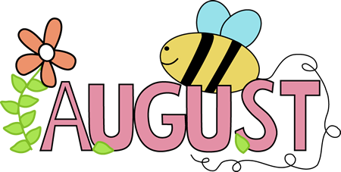

Agenda

- Approving/Correcting the Minutes of the Last Preceding Meeting(s)
- Monthly Progress Report
- Review of Correspondence
- Citizen Comments/Concerns
- New Business
1) One Time Forgiveness on Water/Sewer Bill
2) Purchase of Colorimeter
3) Discuss Sanitary Permit on Rosemont St.
4) Possible Amendment to Ordinance 248-2 for Special Assessment charges
- Treasurer’s Report
- Approval of Vouchers
- Review Delinquent Utility Accounts

This building is accessible to people in wheelchairs. Parking for people with disabilities is available at the north entrance.

