WPS Foundation awards $50,000 to first responders through Rewarding Responders Grant
More than $400,000 awarded since 2014

Marinette — Wisconsin Public Service (WPS) focuses on safely powering communities across northeast and north central Wisconsin every day. To help the brave men and women who work to keep these communities safe, the WPS Foundation is awarding $50,000 to 27 emergency response agencies through its Rewarding Responders Grant.

“Each year, this grant is a chance for us to say thank you to our first responders for their tireless efforts to keep our communities safe,” said Tom Metcalfe, president — WPS. “We’re proud to support these everyday heroes by providing them the essential tools they need to continue to perform at the highest level.”

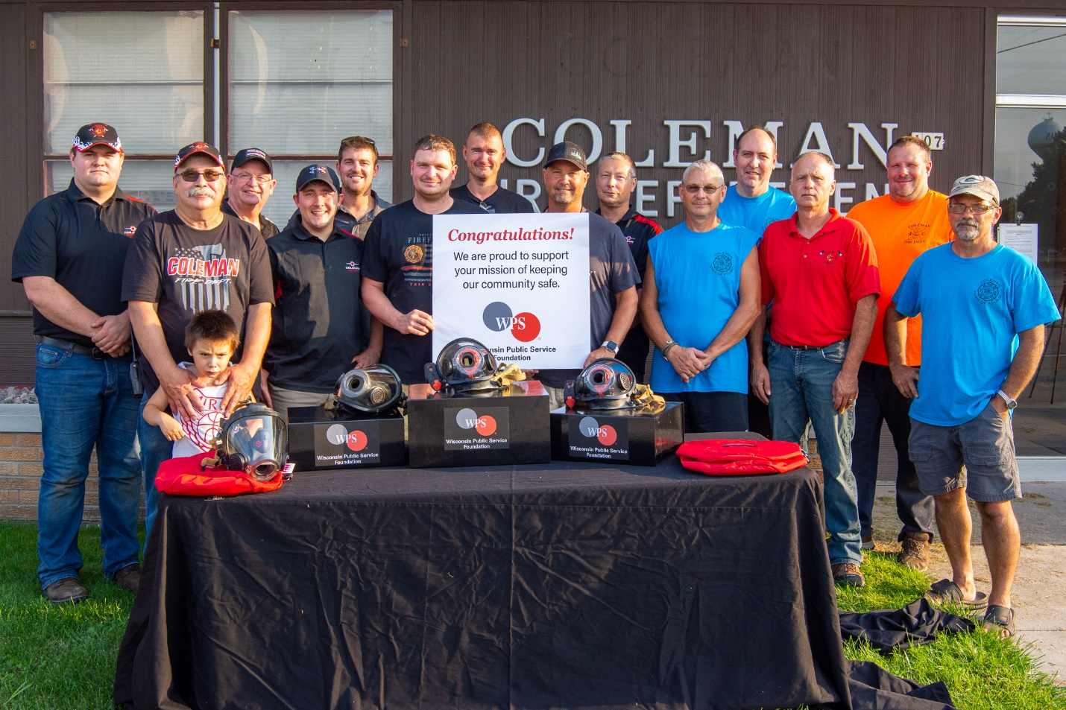
The Coleman Fire Department is among 27 emergency response agencies receiving a 2021 Rewarding Responders Grant from the WPS Foundation. The department is using its grant to purchase new face masks for its firefighters.

The WPS Foundation provides its Rewarding Responders Grant annually to help police, fire and emergency medical services (EMS) agencies purchase lifesaving equipment or important training for their members. Among this year’s recipients is the Coleman Fire Department, which received new firefighting face masks for its firefighters.

“Receiving this grant means a lot to our department, as it will help protect our firefighters and aid in the health of our community,” said Tom Behnke, fire chief — Coleman Fire Department. “Grants from organizations like the WPS Foundation are very important to us. Thank you for your generosity.”

Important tools to help improve safety
Other northern Wisconsin grant recipients include:
- Pound Fire Department: Fire-resistant hoods and flashlights for firefighters
- Little River Fire Department: Portable area work light and accident extrication gloves for firefighters.
- Twin Bridge Rescue Squad (Crivitz): Loading system for ambulance cots
- Wagner Fire Department: Multi-gas detection meter

Grants help hundreds of Wisconsin communities
The Rewarding Responders Grant helps strengthen public safety in communities served by WPS. Since the program began in 2014, the WPS Foundation has awarded more than $400,000 to help nearly 230 agencies improve public safety in Wisconsin.

To receive a grant, emergency response agencies must operate in the WPS service area, and must demonstrate the equipment or training they wish to purchase is part of a well-planned public safety initiative. Grants also may be used to fund safety-related projects that are unique, one-time efforts.

More information about the grant.

Media Contact:
Matt Cullen
Media Relations
920-433-1554
matt.cullen@wecenergygroup.com

