COLEMAN WATER & SEWER UTILITY MEETING

Monday November 8, 2021 at 11:00 am

202 E. Main Street – Coleman, WI 54112

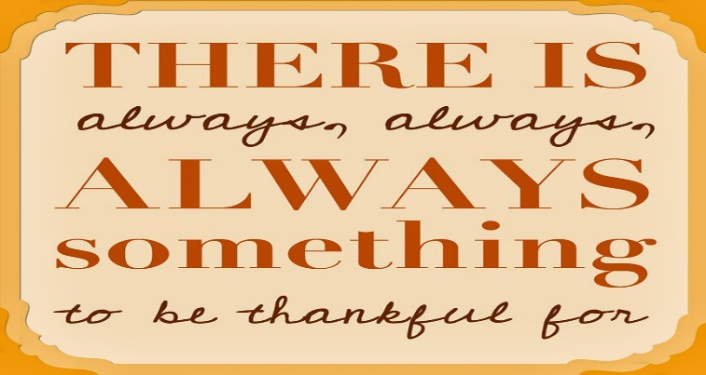

Agenda
- Call To Order
- Roll Call
- Approving/Correcting the Minutes of the Last Preceding Meeting(s)
- Monthly Progress Report
- Review of Correspondence
- Citizen Comments/Concerns
- New Business
1) Badger Labs Quote
2) Discuss/approve action for illegal water use
- Treasurer’s Report
- Approval of Vouchers
- Review Delinquent Utility Accounts
- Adjournment

This building is accessible to people in wheelchairs. Parking for people with disabilities is available at the north entrance.

