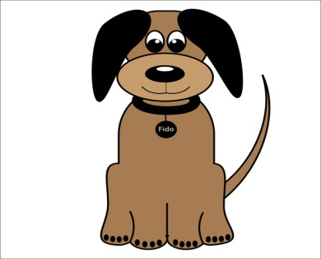
APPLY FOR A DOG LICENSE

Name of Owner: ______________________________________
Residing at: __________________________________________

Name of Dog: _________________________________________

□ Male ($10.00) □ Neutered Male ($5.00)
□ Female ($10.00) □ Neutered Female ($5.00)
□ Add $5.00 late fee to above if paid after April 1st

Breed: _______________________________________________
Color: ________________________________________________

RABIES VACCINATION (Required for all dogs 5 months of age or over)
Date: ____________ Expiration Date: _______________
Vacine MFG: ____________________________________________
Serial # ________________________________________________

Please submit a copy of the Rabies Vaccination, a check made out to the Village of Coleman
And a self addressed stamped envelope to receive your License in the mail.

