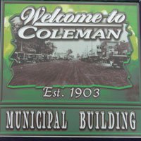

202 E. MAIN ST. * COLEMAN, WI 54112 www.villageofcoleman.com
Phone: 920-897-2234/ Fax: 920-897-4414 clerk@villageofcoleman.com

VILLAGE OF COLEMAN
NOTICE OF POSSIBLE QUORUM
Wastewater Treatment Plant, 718 US BUS 141N, Coleman, WI
The session will take place on Thursday, May 19, 2022, at 10:30 am at the Wastewater Treatment Plan, 718 US BUS 141, Coleman, WI 54112.
Thad Majkowski, Engineer from Cedar Corp, has invited elected officials and municipal staff to participate in a walk thru and answer session at the WWTP. Mr. Majkowski and other staff from Cedar Corp. will be assessing items for the upgrade of the WWTP.
This notice is posted in order to meet the requirements of the Open Meetings Act, in the event that the number of Village Board members present at the meeting makes the Act applicable.
Posted on May 17, 2022
Lori Gross
Municipal Clerk/Treasurer

