VILLAGE OF COLEMAN
MARINETTE COUNTY, WISCONSIN

PRESIDENT:
CLERK/TREASURER:
ASSISTANT CLERK/TREASURER
BOARD MEMBERS:
JEFFREY GOSA
LORI GROSS
MCKENNA KRIESCHER
DAVE PODOSKI
JIM KARBAN
JORDAN GONDECK
JAMES HEYROTH
CAYSE GILLESPIE
SEAN VAN ERMEN

ZONING AND PLANNING COMMISSION:
JEFFREY GOSA
TIM GOULD
RICHARD STANK
AMY LEWIS
JIM KARBAN
JORDAN GONDECK
NANCY STANK

VILLAGE OF COLEMAN
20-YEAR COMPREHENSIVE PLAN

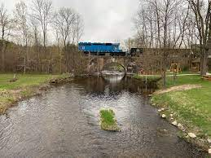
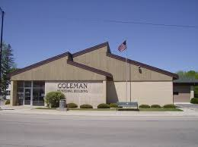

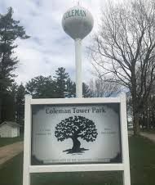

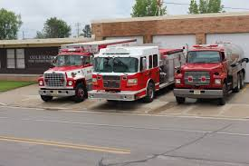
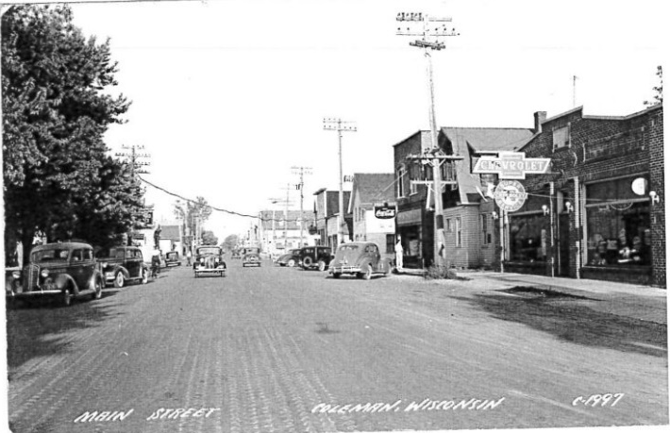

DECEMBER 8TH, 2025
TABLE OF CONTENTS

Chapter 1 – Introduction
1.1 Vision Statement………………………………………………………………………...….....Page 1
1.2 Purpose of the Comprehensive Plan………………………………………………….…….... Page 2
1.3 Defining Goals, Objectives, & Actions……………………………………………...……...…Page 3
1.4 Public Participation Process……………………………………………………………..……Page 3
1.5 Community Inventory……………………………………………………………………..….Page 4
Chapter 2 – Natural & Cultural Resources
2.1 Natural & Cultural Resource Goals & Objectives………………………………………..……Page 7
2.2 Natural & Cultural Resource Policies and Recommendations……………………….………...Page 7
2.3 Natural Resources………………………………………………………………………......…Page 8
2.4 Historic and Cultural Resources………………………………………………………....…...Page 10
Chapter 3 – Housing
3.1 Housing Goals & Objectives…………………………………………………………...……Page 11
3.2 Housing Policies and Recommendations………………………………………………….…Page 11
3.3 Housing Characteristics……………………………………………………………………...Page 12
Chapter 4 – Transportation
4.1 Transportation Goals & Objectives……………………………………………………...…..Page 14
4.2 Transportation Policies and Recommendations……………………………………...………Page 14
4.3 Existing Road System…………………………………………………………………...…...Page 15
4.4 Road Function/Jurisdictional Classification………………………………………...………. Page 15
4.5 Traffic Trends…………………………………………………………………...………...…Page 18
4.6 Additional Modes of Transport……………………………………………………………...Page 19
4.7 Planned Transportation Improvements…………………………………………………...…Page 20
4.8 Transportation Programs………………………………………………………………..…...Page 20
Chapter 5 – Utilities and Communities Facilities
5.1 Utilities and Community Facilities Goals & Objectives…………………………...……….…Page 22
5.2 Utilities and Community Facilities Policies and Recommendations……………………….….Page 23
5.3 Community Facilities……………………………………………………………...…………Page 23
5.4 Utilities……………………………………………………………………………...……….Page 26
5.5 Utilities and Community Facilities Programs……………………………………………..….Page 27
Chapter 6 – Economic Development
6.1 Economic Development Goals & Objectives…………………………………….………….Page 29
6.2 Economic Development Policies and Recommendations……………………………………Page 29
6.3 Labor Force & Employment Characteristics…………………………………………...…….Page 30
6.4 Education and Income Levels…………………………………………………………...…..Page 30
6.5 Economic Development Programs……………………………………………………...…..Page 31
Chapter 7 – Land Use
7.1 Land Use Goals & Objectives………………………………………………………...……..Page 32
7.2 Land Use Policies and Recommendations……………………………………………...……Page 32
7.3 Current Land Use……………………………………………………………………...…….Page 33
7.4 Supply, Demand, and Price Trends of Land……………………………………………...…..Page 33
7.5 Development Regulations………………………………………………………………...…Page 34
7.6 Future Land Use………………………………………………………………………...…..Page 35
7.7 Land Use Programs………………………………………………………………………....Page 37
Chapter 8 – Intergovernmental Relations
8.1 Intergovernmental Relations Goals & Objectives………………………………………..…..Page 38
8.2 Intergovernmental Relations Policies and Recommendations……………………………..…Page 38
8.3 Cooperative Practices………………………………………………………………..………Page 39
8.4 Intergovernmental Relations Programs…………………………………………………...…Page 40
Chapter 9 – Implementation
9.1 Implementation Goals & Objectives……………………………………………………..…..Page 41
9.2 Implementation Policies and Recommendations………………………………………....…..Page 42
9.3 Implementation Tools…………………………………………………………………..….. Page 42
9.4 Plan Amendments……………………………………………………………………...……Page 44
9.5 Measuring Plan Progress………………………………………………………………….....Page 45
9.6 Implementation Programs…………………………………………………………………..Page 45
Lists of Tables
Table 1 – Village of Coleman Population………………………………………………………….……..…Page 4
Table 2 – Village of Coleman Population Statistics……………………………………………………..….Page 5
Table 3 – Age Distribution Percentages……………………………………………………………….........Page 6
Table 4 – Population by Household Type…………………………………………………………….….....Page 6
Table 5 – Housing Demographics………………………………………………………………………….Page 12
Table 6 – Age of Housing Units…………………………………………………………………………....Page 13
Table 7 – Annual Average Daily Traffic Counts………………………………………………………...…Page 18
Table 8 – Accident Summary………………………………………………………………………………Page 18
Table 9 - Employment Percentages per Sector………………………………………………………….…Page 30
Table 10 – Household Income……………………………………………………………………….…….Page 31
Table 11 – Population by Highest Education………………………………………………………...…….Page 31
Table 12- Parcel Characteristics……………………………………………………………………..……..Page 33
Table 13-Equalized Valuation………………………………………………………………………….…..Page 34
Table 14 – Intergovernmental Arrangements………………………………………………………………Page 39

Lists of Maps
Map 1 - USGS Quadrangle …………………………………………………………………………...…Chapter 2
Map 2 – Water and Environmental Features………………………………………………………......…Chapter 2
Map 3 - Road Functional/Jurisdictional Classification……………………………………………......…Chapter 4
Map 4 – Community Facilities and Services………………………………………………………….…Chapter 5
Map 5 – Existing Land Use………………………………………………………………………………Chapter 7
Map 6 – Zoning…………………………………………………………………………………………..Chapter 7
Map 7 – General Plan Design……………………………………………………………………………Chapter 7

CHAPTER 1
INTRODUCTION

This section of the Village of Coleman Comprehensive Plan provides a summary of the village’s resource elements. The village’s past trends and potential forecasts for population, housing, economic development, etc. are also illustrated in this chapter.
Ultimately, the information described in this portion of the village’s comprehensive plan provides the foundation for the development of the Village of Colemans’ General Plan Design.

1.1 VISION STATEMENT

Village of Coleman 20-Year Vision Statement

The Village of Coleman is a safe and friendly community. The area maintains its “small-town”, rural character and sense of community with the idea that small town living doesn't mean small town ideas. The downtown area and Main Street are the focus for businesses, community activities, and events. Restored Buildings and new businesses on Main Street reflect the small-town roots of the area’s history and character. The USH 141-Interchange area in south Coleman offers opportunity for local employment through planned and coordinated business and light industrial development afforded through local investments of water and sewer services. Expecting some residential growth, the village strives to maintain the natural beauty while planning for and coordinating growth. Community identity is developed through investments in sense of place items such as community character signage, cleanliness, excellent school systems, parks, and trails. The goal of planning and implementation of the comprehensive plan is to guide and focus development and improve quality of life through decision making that represents the needs and desires of the community.

Page 1
1.2 PURPOSE OF THE COMPREHENSIVE PLAN
PURPOSE OF THE COMPREHENSIVE PLAN
The Village of Coleman 20-Year Comprehensive Plan is a legal document that provides the policy framework for which village officials will base their development decisions. Over the next 20 years, the village will need to address a number of land use issues that will likely have an impact on various aspects of community. This comprehensive plan will serve as a guide to ensure decisions regarding future land uses are consistent and take into account housing development, provision of public services, economic development, transportation expansion, and environmental protection.
The General Plan Design (Map 7) designates areas of the village for preferred land use activities and is the desired goal to be achieved through the implementation of this comprehensive plan. The General Plan Design, along with the village’s development strategies, shall be used in conjunction with Marinette County's zoning ordinances, local land use ordinances, supporting planning materials, and other implementation tools to make informed land use decisions in the Village of Coleman over the next 20 years.
State Planning Legislation
As outlined in the Comprehensive Planning Legislation, s.66.1001, Wis. Stats., the Village of Coleman 20-Year Comprehensive Plan addresses the required nine plan elements.

• Economic Development
• Intergovernmental Cooperation
• Land Use
• Implementation
• Issues and Opportunities
• Housing
• Transportation
• Utilities and Community Facilities
• Agriculture, Natural, and Cultural Resources

Page 2
The comprehensive planning legislation (s.66.1001, Wis. Stats.) further states:
"Beginning on January 1, 2010, if a local governmental unit engages in any of the following actions, those actions shall be consistent with that local governmental unit's comprehensive plan:
(a) Official mapping established or amended under s. 62.23 (6).
(b) Local subdivision regulation under s. 236.45 or 236.46.
(c) County zoning ordinances enacted or amended under s. 59.69.
(d) City or village zoning ordinances enacted or amended under s. 62.23 (7).
(e) Town zoning ordinances enacted or amended under s. 60.61 or 60.62.
(f) Zoning of shorelands or wetlands in shorelands under s. 59.692, 61.351 or 62.231."
1.3 DEFINING GOALS, OBJECTIVES, & ACTIONS

This document describes a variety of goals, objectives and actions the village has identified to help it respond to issues and opportunities identified in this plan. Definitions are below:
• Goal: A goal is a statement that describes a desired future condition. The statement is broad in scope and
describes general concepts or things the community hopes to accomplish.
• Objective: An objective is a statement that describes a specific course of action to achieve a goal or
address an issue.
• Actions: An action describes a specific effort that will be undertaken to achieve a specific goal or
objective.

1.4 PUBLIC PARTICIPATION PROCESS

Community Survey
A community survey was conducted in August 2025 to solicit the feelings residents and landowners had toward existing village services and to gain their insight on village planning and development. In addition, respondents were asked to delineate where they felt development (residential, commercial, and industrial) should occur in the village. The surveying process provided valuable input necessary to create the goals, objectives, policies, and programs for the comprehensive plan. A summary of the survey's general themes is highlighted below.
- The respondents' overwhelming concern to maintain roadway conditions
- The desire to maintain a small-town atmosphere
- The desire for the village to take action and clean up unsightly areas
- Support for the development of housing
- Support for community planning
The complete results of the community survey can be found on the Village of Coleman website. (www.villageofcoleman.com)

Public Participation Exercise
A Public Participation exercise was conducted with village residents to describe the future of various elements discussed in the village’s comprehensive plan, including future land uses, economic development, housing, etc. The visioning process was used to provide a foundation to generate development strategies (i.e. goals, objectives, policies, and programs) to implement in the Village of Coleman Comprehensive Plan.
A workshop was done during this time to collect any potential resolutions to issues and concerns that were identified during the public participation meeting and upon the completion of the community survey.

Planning Process
In early 2025, the Village initiated a process to update its 2003 plan. The State planning law -66.1001 requires
that a comprehensive plan be updated every ten years. Village staff worked with the Village Planning and Zoning Commission to update the plan. The Planning and Zoning Commission met in July 2025 for their first meeting on updates of the plan, and sending out the community survey. The Planning and Zoning Commission met again in September 2025 to go over the community survey results and results from the public participation. A final Planning and Zoning Commission meeting was held in October 2025 to review the final draft and recommend adoption of the plan to the Village Board. A public hearing was held on December 8th, 2025.
Page 3

1.5 COMMUNITY INVENTORY

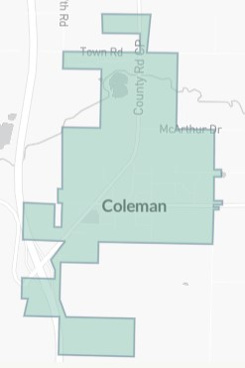
Description of Planning Area
Coleman is located in the South-West portion of Marinette County and currently consists of 635 acres. The 635 acres consist of 505 parcels.
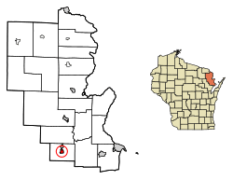

Village of Coleman boundary map
Village of Coleman location in Marinette County

History
The Village of Coleman developed significantly in the early 1880’s when railroad lines were built in 1882 between Coleman and Pound, and then in 1884 when the railroad line extended toward Crivitz and Marinette. Logging was important in the area between 1880’s and 1910. The Village of Coleman was incorporated in 1903. With time, as logging declined, the population and economic patterns shifted. Agriculture became more significant. Infrastructure (roads, schools, utilities) improved gradually.

Demographics
This analysis is intended to describe the existing demographics of the Village of Coleman and identify the major demographic trends impacting Coleman over the next few decades.

Table 1 - Village of Coleman Population

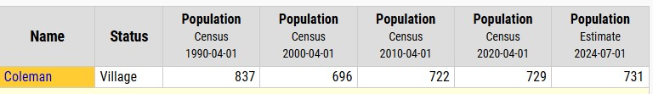
Source: https://citypopulation.de/en/usa/wisconsin/admin/marinette/5507516250__coleman/
This Table 1 Shows the population by census as well as an estimate for 2024. Based on the table of actual census data from 2010 we have been somewhat steady in population size in most recent years.
Page 4
The following Table (Table 2) shows an overview of demographic change within the Village of Coleman from 2019 to 2023 along with projections from 2024 to 2029 based on recent population trends.

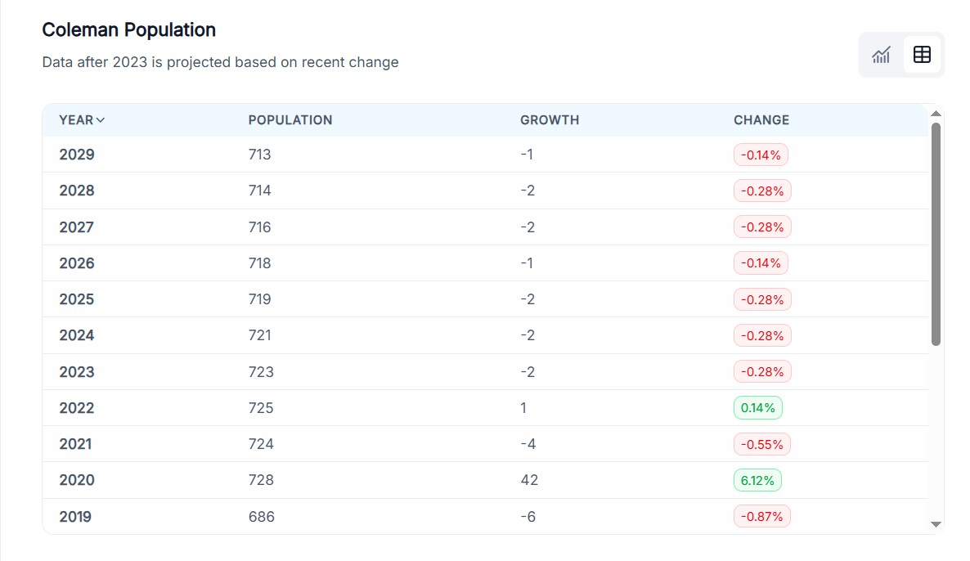
Table 2- Village of Coleman Population Statistics

Source: https://worldpopulationreview.com/us-cities/wisconsin/coleman#:~:text=Coleman%20has%20a%202025%20population,a%20poverty%20rate%20of%205.74%25.

Table 3 shows the Age Distribution percentages for Village of Coleman compared to Marinette County and the State of Wisconsin. The graph shows that Village of Coleman has a much higher percentage of young children, Adults 25-34 years of age, and also senior citizens aged 85+. Village of Colemans median age is 34.2.



Page 5
Table 3- Age Distribution Percentages

Source: U.S. Census Bureau (2019-2023). Sex by Age American Community Survey 5-year estimates. Retrieved from <https://censusreporter.org>

Housing
The village has an estimated 390 households with approximately 50% of those are occupied by married couples. The average household size in the Village of Coleman is 2.2 persons per household, which is the same as Marinette County and a small fraction under the state of Wisconsin average household size which is 2.4 persons per household. The median value of an owner-occupied housing unit is $152,600.

Table 4 – Population by Household Type

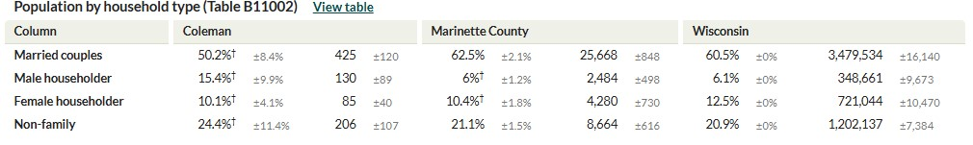
Source: Census Bureau ACS 5-Year Estimate

Page 6

CHAPTER 2

NATURAL AND CULTURAL RESOURCES

This section provides an inventory and assessment of natural and cultural resources of the Village of Coleman. As land development patterns are directly related to the resources base, these features need to be considered before making any decision concerning future development within the community.

Issues
No significant issues identified

2.1 NATURAL AND CULTURAL RESOURCE GOALS AND OBJECTIVES
- Goal: Maintain water quality in existing river and stream corridors.
  - Objective:
    - To preserve and enhance the water quality of existing river and stream corridors by minimizing pollutant inputs and implementing sustainable land and water management practices to support healthy aquatic ecosystems and ensure safe water for human use.
  - Action:
    - Conduct regular water quality monitoring and support compliance with water quality standards.
- Goal: Recognize and protect historic resources in the community
  - Objective:
    - Recognize and support the preservation of historic resources in the Village.
    - Discourage developments that would damage existing historic sites or structures.
  - Action:
    - Work with Marinette County and the State of Wisconsin to identify and preserve existing historic resources.
    - Actively participate in a county-wide survey of historic resources and sites.

2.2 NATURAL AND CULTURAL RESOURCE POLICIES AND RECOMMENDATIONS
- Environmental corridors shall be defined by location of WDNR designated wetlands and FEMA’s designated floodplains.
- Review proposals for the development of properties abutting historic resources to ensure that land use or new construction does not detract from the architectural characteristics and environmental setting of the historic resource.
- Structural development or concentrated animal numbers shall be directed away from 100-year floodplains based on FEMA maps.
- Historic designations will be encouraged, when appropriate, for the purpose of preserving and protecting its character through the use of Federal and State Designation Process.
Page 7
2.3 NATURAL RESOURCES
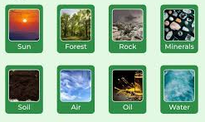
Soils
Soil is composed of varying proportions of sand, gravel, silt, clay, and organic material. The composition of a soil must be evaluated prior to any development, as varying limitations exist for each soil. The following presents the type of soil association that makes up the entire Village of Coleman.
Emmet-Charlevoix Association – Deep nearly level to steep, well drained and somewhat poorly drained, loamy soils on moraines and drumlins.

Farmland and Woodland
Within the small footprint of Coleman, only a small portion is forest/woodland, since much of the village tends to be residential, commercial, roads etc. Most of the farmland/woodland lies on the outskirts of the village limits in adjacent towns.

Watersheds and Drainage
A watershed can be defined as an interconnected area of land, draining from surrounding ridge tops to a common point such as a lake or stream confluence with a neighboring watershed. All lands and waterways can be found within one watershed or another. In Wisconsin, watersheds vary in scale from major river systems to small creek drainage areas and typically range in size from 100 to 300 square miles. River basins encompass several watersheds. There are 32 river basins in Wisconsin which range in size from 500 to over 5,000 square miles.
Wisconsin has redesigned its natural resource management approach around the concepts of ecoregions and watersheds. This shift in approach recognizes that working with the natural structure and function of resources, as opposed to strictly political or social boundaries, will provide more successful results.
The Village of Coleman is within the Upper Green Bay Basin as designated by the Wisconsin Department of Natural Resources (WDNR). The basin includes 16 watersheds that drain to Green Bay. More than 60% of the basin is forested and 2,654 stream miles drain the basin.
The entire Village of Coleman is located within Little Peshtigo River Watershed.

Wetlands
According to the United States Environmental Protection Agency, wetlands are areas where water covers the soil, or is present either at or near the surface of the soil all year or for varying periods of time during the year, including during the growing season. Water saturation (hydrology) largely determines how the soil develops and the types of plant and animal communities living in and on the soil. Wetlands may support both aquatic and terrestrial species. The prolonged presence of water creates conditions that favor the growth of specially adapted plants (hydrophytes) and promote the development of characteristic wetland (hydric) soils.
Page 8
Wetlands may be seasonal or permanent and are commonly referred to as swamps, marshes, fens or bogs. Wetland plants and soils have the capacity to store and filter pollutants ranging from pesticides to animal wastes. Wetlands can make lakes, rivers and streams cleaner, and drinking water safer. Wetlands also provide valuable habitat for fish, plants, and animals. In addition, some wetlands can also provide the replenishment of groundwater supplies. Groundwater discharge is common from wetlands and can be important in maintaining stream flows, especially during dry months.
Local, state and federal regulations place limitations on the development and use of wetlands and shorelands. The Wisconsin Department of Natural Resources (WDNR) has inventory maps for each community that identifies wetlands two acres and larger. The wetland inventory map should be consulted in conjunction with this document whenever the village review development proposals in order to identify wetlands and to ensure their protection from development.
Within the Village of Coleman there are 92 acres of wetlands primarily located adjacent to the Little Peshtigo River and along a tributary which runs through the southeast corner of the village. (See Water & Environmental Features Map)

Floodplains
For planning and regulatory purposes, the floodplain is normally defined as those areas, excluding the stream channel, that are subject to inundation by the 100-year recurrence interval flood event. This event has a one percent chance of occurring in any given year. Because of this chance of flooding, development in the floodplain should be discouraged and the development of park and open space in these areas encouraged. The floodplain includes the floodway and flood fringe. The floodway is the portion of the floodplain that carries flood water or flood flows, while the flood fringe is the portion of the floodplain outside the floodway, which is covered by waters during a flood event. The flood fringe is generally associated with standing water rather than rapidly flowing water.
Wisconsin Statute 87.30 requires Counties, Cities and Villages to implement floodplain zoning. In addition, the Federal Emergency Management Agency (FEMA) has developed flood hazard data. Under the authority if the National Flood Insurance Act of 1968, FEMA conducted studies to determine the location and extent of flood lands and the monetary damage risks related to the insurance of urban development in Foodland areas.
The majority of floodplains within the village are associated with the Little Peshtigo River and its tributaries. The Village of Coleman has 82.2 acres of floodplains. (See Water and Environmental Features Map)

Surface Water Features
The primary river, stream, or creek feature found within the Village of Coleman is the Little Peshtigo River. According to The Upper Green Bay Basin Integrated Management Plan, the river has a total length of 19 miles. According to the report, the Little Peshtigo River has unspecified nonpoint sources of pollution, however there are no water quality problems present.

Ground Water Quality
The DNR regulates municipalities, industrial facilities and significant animal waste operations discharging wastewater to surface waters or groundwater of the State of Wisconsin through the Wisconsin Pollutant Discharge Elimination System (WPDES) Permit Program. No person may legally discharge to waters of the state without a permit issued under this authority. According to the DNR's database the Coleman Wastewater Treatment Facility is a municipal permit holder.
Page 9

Wildlife Resources and Habitat
Wildlife Habitat can simply be defined as the presence of enough food, cover, and water to sustain a species. Marinette county and the Village of Coleman landscape provides habitat for a variety of plants, birds, mammals, amphibians, reptiles, and fish. Natural areas are critical components of the states biodiversity and may provide habitat for rare, threatened, and endangered species. Marinette County is a top numbers producer for whitetail deer, as the county’s habitat is ideal for whitetail populations.

Threatened and Endangered Species
Threatened and Endangered species list can be found on the Wisconsin DNR Site by going to https://p.widencdn.net/byxof6/ER001

2.4 HISTORIC AND CULTURAL RESOURCES
The National Register of Historic Places recognizes properties of local, state and national significance. Properties are listed in the National Register because of their associations with significant persons or events, because they contain important information about our history or prehistory, or because of their architectural or engineering significance. The National Register also lists important groupings of properties as historic districts. In addition, the National Park Service highlights properties that have significance to the nation as a whole by conferring them the status of National Historic Landmark.
The Wisconsin State Register of Historic Places parallels the National Register. However, it is designed to enable state-level historic preservation protection and benefits. Most of the properties in Wisconsin listed in the National Register are also listed in the State Register.
According to the National and State Register, no historic places are listed within the Village of Coleman.
The Wisconsin Architecture & History Inventory (AHI), provided by the Wisconsin Historical Society lists historical and architectural information on properties in Wisconsin. The AHI contains data on buildings, structures and objects that illustrate Wisconsin's unique history. The majority of properties listed are privately owned. Listed properties convey no special status, rights or benefits. Eleven AHI sites were listed as being located within Coleman, including several houses and commercial structures.

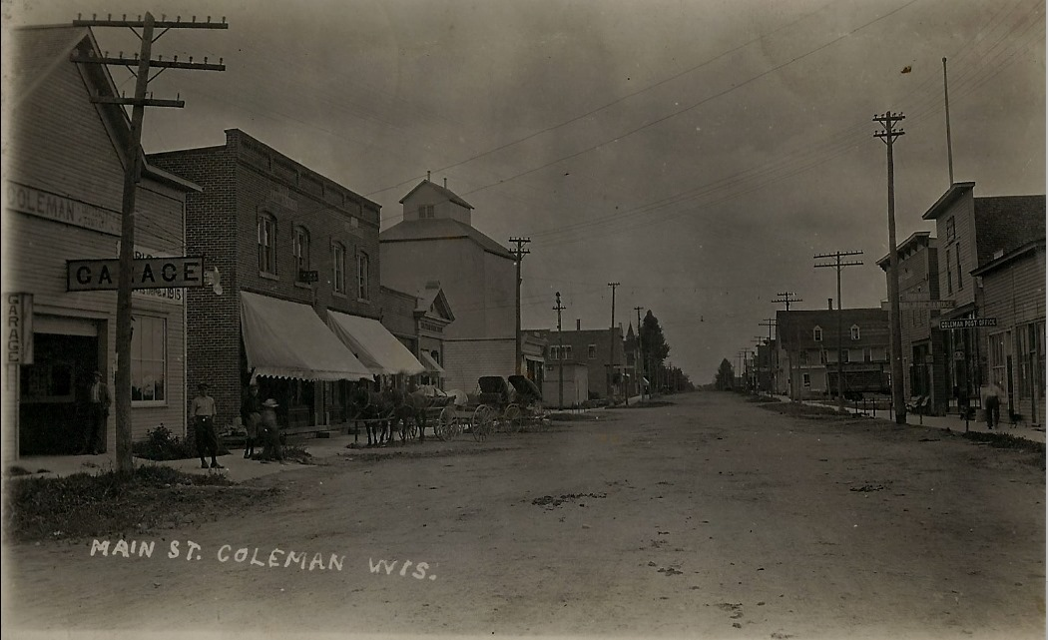

Page 10
CHAPTER 3

HOUSING

The comprehensive planning process required the village to analyze the impact of local policies and regulations on the development of various types of housing. The analysis and inventory should be used to examine current and future housing needs within the community, which should therefore result in policies that provide opportunities for development of the types and amounts of housing expected to be needed over 20-years planning horizon.
Issues
Lack of availability of housing
3.1 HOUSING GOALS & OBJECTIVES
- Goal: Plan for a variety of housing and development opportunities that are consistent with the character and service capabilities of the Village of Coleman.
  - Supporting Objectives:
    - Retain single family residences as the preferred type of housing supply in the village
    - Explore opportunities to provide incentives for developers and home builders to create quality housing that is affordable for all income types.
    - Support the location of manufactured homes within the village that feature designs similar to site-built homes and are built to state standards.
    - Strengthen established neighborhoods through encouraged conservation improvements in the quality of existing housing.
    - Enforce municipal housing codes
  - Actions:
    - Identify sites for future residential development.
    - Obtain land for more residential infrastructure.

3.2 HOUSING POLICIES AND RECOMMENDATIONS
- Plan for a sufficient supply of developable land that allows for a variety of housing types.
- Manufactured homes shall meet feature designs similar to “stick built” homes.
- Cluster residential development will be promoted to minimize land use impacts while accommodating development and green space.

Page 11
3.3 HOUSING CHARACTERISTICS

Housing Supply
The Village of Coleman has approximately 419 structures/units located in the village which it is estimated to have 61 % of them being single units and 39% being multi-unit structures shown in table 5. Ownership of occupied units has dropped to only 47%, while 53% of the units are renter occupied.

Table 5 - Housing Demographics
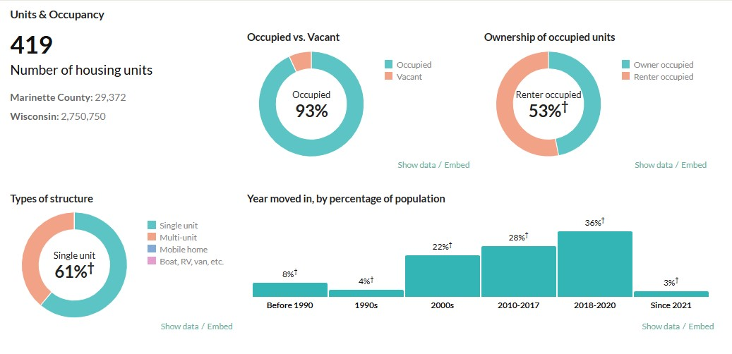

Citation: U.S. Census Bureau (2023). American Community Survey 5-year estimates. Retrieved from Census Reporter Profile page for Coleman village, Marinette County,WI <http://censusreporter.org/profiles/06000US5507516250-coleman-village-marinette-county-wi/>

Age of Housing Units
The age of the housing stock is an important element to be analyzed when planning for the future. If there is a significant amount of older housing units they will need to be replaced, rehabilitated, or abandoned for new development within the planning period.

Page 12
Table 6 - Age of Housing Units

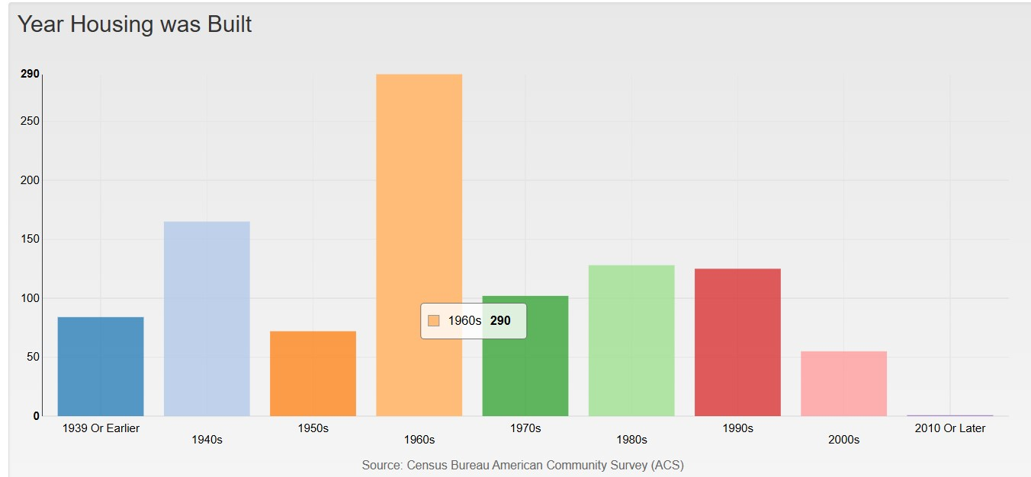

Table 6 shows that a majority of the housing units were built in the 1960’s with multiple other units being built before the 1960’s. The Village of Coleman also has to take into consideration the amount of building permits that have been received in the past 5 years for these house rehabilitations for these homes located within the Village of Coleman. In 2020, the building Inspector issued 59 building permits. The following year, in 2021, 42 building permits were issued to residents and in 2022, 38 building permits were issued.

Availability of Land for Development /Redevelopment of Housing
Many parcels, which are currently privately owned can be used for residential development. The Village of Coleman also has available parcels located on Robinette Trail, along with a private owner that also has parcels for sale on that same roadway.

Housing for All Income Levels, Age Groups, and for Persons with Special Needs
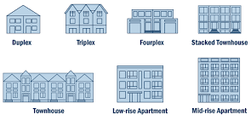
An increasing number of people cannot find housing in their community that is suitable for their stage in life. This situation requires that the Village of Coleman pursue strategies, while also monitoring and encouraging the development of a range of housing choice to meet the needs of people with different income levels with various needs. As the general population ages, affordability, security, accessibility, proximity to services, transportation, food and medical facilities will all become increasingly important. These Trends will have land use, transportation, community facility, and economic implications. Marinette County offers a voucher program for housing assistance.
Page 13

CHAPTER 4
TRANSPORTATION

The land use patterns of a community and region are tied together by the transportation system, including roadways, railroads, airlines, trails, waterways, etc. The residents, businesses, agricultural producers, and manufacturers all rely upon a dependable transportation system to function and provide linkages to areas beyond their borders. The transportation network plays a major role in the efficiency, safety and overall desirability of a community as a place to live and work.

Issues
Road Maintenance - There is a need to determine, prioritize and fund road maintenance and road
improvements.
Sidewalk Policy – There is a need for an enforced sidewalk policy especially in developing areas and along major pedestrian routes (around the high school, etc.). This will improve the transportation options for all
residents of the Village.
Trail System – The community identified the need for intra-community trail system linking existing parks, businesses, and community facilities.

4.1 TRANSPORTATION GOALS AND OBJECTIVES
- Goal: Provide a safe and well-maintained transportation network
  - Objectives:
    - When reviewing development proposals, consider future road connections, setbacks, access points, and other traffic impacts that the proposal may have on the existing transportation network.
    - Consider bicycle and pedestrian safety needs when new roads are proposed or when major roadway improvements are made.
    - Increase the use of the PASER evaluation rating system for road maintenance and project budgeting purposes.
  - Action:
    - Review and revise relevant ordinances or policies.
    - Conduct annual road assessments using PASER.

4.2 TRANSPORTATION POLICIES AND RECOMMENDATIONS
- Utilize the PASER (Pavement Service and Evaluation Rating System) for road maintenance and project budgeting to manage local road improvement projects.
- Area development plans shall be required as part of any submittal of any residential development plans within the village. This will allow the community to assess the future connection and traffic flow impacts on surrounding properties.
- Dead-End Roads and Cul-de-sacs shall be avoided to the extent practicable.
Page 14
- Require developers to bear an equitable share of the costs for improvements and extensions to development.
- The village will consider bicycle and pedestrian development and/or safety improvements when new roads are proposed or when roadway improvements are made.
- The existing road network and public facilities and services will be utilized to accommodate new development to the maximum extent possible.

4.3 EXISTING ROAD SYSTEM
The existing road system for the Village of Coleman is illustrated in Map 3, Road Functional/Jurisdictional Characteristics. The Village of Coleman's roadway configuration is a typical main street type layout with connecting side street and outlets, which is also heavily influenced by traffic patterns occurring on Highway 141 and Business 141.
The general traffic circulation patterns through the Village of Coleman are as follows:
- Business 141 provides for north/south travel through Coleman, and serves as the primary transportation route for trips by local residents. This highway connects to USH 64 at the north end and USH 41 at the south end.
- County Trunk Highway (CTH) B, with support from local roads, provides for east/west travel through the village.
- In the Village of Coleman, Business 141 and CTH B (east and west Main Street) provide the primary transportation routes. The majority of other roads within the village either directly connect to are easily accessed from these roads.
As depicted on Map 3, the road system is composed of three levels of government jurisdiction. These include the system of local roads, the county system of trunk highways, and the state highway system.

4.4 ROAD FUNCTION/JUSRISDICTIONAL CLASSIFICATION
The three levels of jurisdictional roadway (local, county, and state) often are considered to represent the functional classification of roads used for planning and design purposes. The division of the roadway into the functional classes, such as arterials and collectors, represents a classification relative to the principal service the roadway is intended to serve. The functional classification is generally the basis of funding, construction, and maintenance.
The functional classification for rural areas often depicts the use of the state and federal roads as arterials, while county and town roads serve as collectors within the roadway system. These terms are explained below based on definitions provided by the Wisconsin Department of Transportation. Although the definitions are somewhat formal, they attempt to explain the principal role of each type of roadway.
Page 15

Wisconsin Department of Transportation further identifies the criteria used to determine the class of each road within a community. https://wisconsindot.gov/Documents/projects/data-plan/plan-res/fc-criteria.pdf

Map 3
Road Functional/Jurisdictional Classification
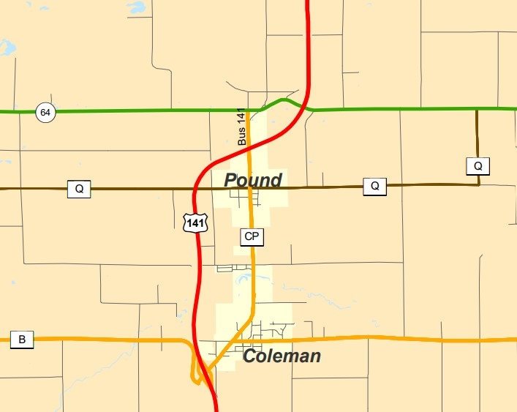

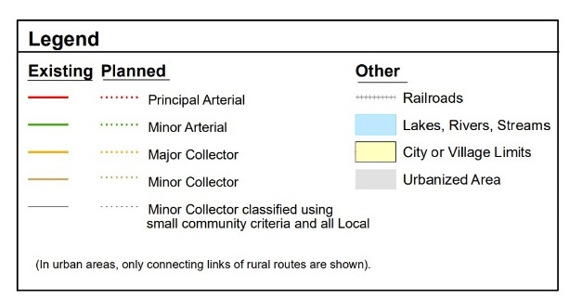

Page 17
4.5 TRAFFIC TRENDS

Traffic Volume Trends

Table 7 – Annual Average Daily Traffic Counts

Source: Wisconsin Department of Transportation, 2025

Average Annual Daily Traffic (AADT) counts are calculated by multiplying raw hourly traffic counts by seasonal, day-of-week, and axle adjustment factors. The daily hourly values are then averaged by hour of the day and the values are summed to create the AADT count.
Table 7 shows that there was a decrease in traffic from 2009 to 2022 along Business 141, but an increase in traffic along USH 141. Decreased counts of traffic into the Village of Coleman greatly reflects the USH 141 overpass construction.

Accident Locations
To further analyze the Village of Coleman’s road system, motor vehicle accidents are studies to identify problem areas. The frequency of motor vehicle accidents tends to correlate directly with traffic volumes. However, the design and condition of the road may also have an impact on the accident rate.
The following table displays the number of accidents that occurred in the Village of Coleman from 2019 to 2024.

Table 8 – Accident Summary

Source: Wisconsin Department of Transportation, 2025
None of the accidents identified had fatalities.

Page 18
4.6 ADDITIONAL MODES OF TRANSPORT

Air Service
The nearest airport is the Crivitz Municipal Airport. This airport is classified as a Basic Utility­A airport, indicating that it is designed to accommodate aircraft of less than 6,000 pounds gross weight, with approach speeds below 91 knots and wingspans of less than 49 feet. Such aircraft are typically single-engine piston. According to the Wisconsin State Airport System Plan 2020, this airport is anticipated to remain under this classification until 2020. The next closest airport is the Oconto Municipal Airport, designated as a Basic Utility-B airport. For international, air cargo and commercial service the nearest airport is the Austin Straubel International Airport located in Green Bay.

Rail Services
The Escanaba and Lake Superior Railroad generally runs along the old USH 141, which is now Business 141 since the construction of the overpass, almost directly splitting the Village of Coleman. This rail line begins-in Green Bay, where it has access to several other rail lines, and moves north with branch lines extending to the City of Marinette and into northern Michigan. The Escanaba and Lake Superior Railroad is classified by the WDOT as a local railroad, indicating that it is not a Class I or Regional Railroad and is engaged primarily in line-haul service. There is a total of 116 miles of this local railroad in Wisconsin. The WDOT currently has no plans to restore passenger railroad service to this line.
Availability of these rail lines provides expanded opportunities for economic expansion or industrial development within Coleman.

Truck Routes
According to the WDOT's 2001 Truck Operators Map, STH 64 and U.S. 141 are official designated highways. These designations indicate that operation of vehicles and combinations of vehicles for which the overall lengths cannot be limited. Trans. 276 clarifies other statutory provisions or federal rules affecting the weight, width, and length of vehicles and combinations of vehicles and the number of vehicles in combination. The Wisconsin Truck Operators map conforms to Highways & Transportation Laws & Rules, Chapter Trans. 276, Size and Weight of Vehicles and Vehicle Combinations.

Bicycle and Walking Corridors
According to the Wisconsin 2000/2001 Biking Guide, there are no identified on-road, mountain bike or bike touring trails within Coleman. Within the Village of Coleman there are no designated pedestrian or bicycle routes and/or facilities. However, the village does provide better accommodations for pedestrian and bicycle routes due to the more condensed village road system.
The Village of Coleman also owns and maintains Skarda Park that has a small walking trail throughout.

Rustic roads
There are no rustic roads in the Village of Coleman.
Page 19
4.7 PLANNED TRANSPORTATION IMPROVEMENTS

County Highway projects
The Marinette County Highway Department performs both general and winter maintenance including: patching, crack filling and seal coating of pavement, shoulder maintenance and vegetation control, bridge and culvert maintenance, litter and trash pickup, guard rail installation and repair, signing, pavement marking, and traffic control. Winter maintenance includes: the application of sand and salt, plowing, shoveling and hauling snow. Additionally, the department provides road construction, pavement resurfacing (blacktopping), bridge repair, culvert repair and installation. To effectively accomplish these activities, storage, maintenance and repair facilities are operated at various locations (Peshtigo, Crivitz and Pembine).

Village Highway and Road Projects
The Village of Coleman received $26,578.76 for General Transportation Aids and Connecting Highways in 2024. General Transportation Aids help defray the costs of constructing, maintaining and operating roads and streets under local jurisdiction. Connecting Highway Aids reimburse municipalities for maintenance and traffic control of certain state highways within municipalities. This funding helps to provide the required maintenance and construction conducted on roads within the village.
Resurfacing Projects: The Village has plans to resurface most roads located in the Village of Coleman that have not been resurfaced in the last 10 years and include curb and gutter in areas where needed. When redoing existing roads close to parks and schools the Village of Coleman plans to add sidewalks where needed.
Road Projects: Robinette Trail will be constructed by the year 2026 on land recently purchased by the Village of Coleman. The Village of Coleman had recently purchased new land for additional lots to be able to add new infrastructure, whether that be residential single homes or multi-family units.
Local roads are typically a very significant item in a local budget. Coordinating road maintenance, reconstruction and development will be a significant issue considering the current status of state budgets and funds distributed to local government through road aids and shared revenue. Planning, managing development, and coordinated land use policy, in light of transportation impacts, will play an important role in local government.

4.8 TRANSPORTATION PROGRAMS

Pavement Surface Evaluation Rating (PASER) – The Wisconsin Department of Transportation (WDOT)
requires all incorporated communities to prepare a Pavement Management Plan (PMP) using a pavement rating
system for their local roads. The data from these plans is intended to provide the foundation for the Wisconsin Information System for Local Roads (WISLR), which is a computer resource that will enable communities and the State to begin to assess Wisconsin’s local roadway system.
The PASER system, which was designed by the Transportation Information Center of the University of
Wisconsin-Madison, is the rating system used most by Wisconsin communities. PASER rates road surfaces on a
scale of 1 to 10. This scale is broken down as follows:
• “1” and “2” = very poor condition
• “3” = poor condition
Page 20
• “4” and “5” = fair condition
• “6” and “7” = good condition
• “8” = very good condition
• “9” and “10” = excellent condition
In addition to its use in the new WISLR, the rating system gives communities a detailed assessment of the
appropriate maintenance method for each road segment under their jurisdiction. This assessment is then
incorporated into the community’s PMP.

Local Road Improvement Project (LRIP) – Established in 1991, the Local Road Improvement Program (LRIP) assists local governments in improving seriously deteriorating county highways, town roads, and city and village streets. LRIP is a reimbursement program which pays up to 50% of total eligible costs, with local governments providing the balance. LRIP projects are awarded every two years on a biennial budget cycle.

Wisconsin Information System for Local Roads - The Wisconsin Information System for Local Roads (WISLR) is a web-based data management tool developed by the Wisconsin Department of Transportation (WisDOT) to help local governments collect, maintain, and analyze information about their local road networks. It includes features such as GIS mapping and pavement condition tracking, which support asset management, planning, and budgeting. Local governments are required to submit pavement condition ratings every two years, and access is provided through the state's Web Access Management System (WAMS). WISLR plays a critical role in determining eligibility for several state and federal funding programs, including the Local Roads Improvement Program (LRIP), Agricultural Roads Improvement Program (ARIP), and Surface Transportation Program–Local (STP-L), all of which use WISLR data to assess road condition and classification. While the system enhances consistency and statewide planning, its effectiveness relies heavily on the accuracy and timeliness of local data submissions.

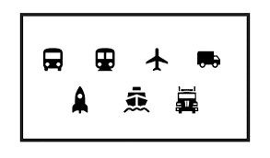

Page 21

CHAPTER 5
UTILITIES AND COMMUNITY FACILITIES

This element contains information about existing utilities and community facilities in the Village of Coleman. Facilities discussed in this element include administrative facilities, public buildings, police, fire, and emergency medical services, schools, quasi-public facilities, parks, solid waste and recycling, communication and power facilities, sanitary sewer, water, stormwater management, and health and daycare facilities.
Addressing community service needs is becoming even more challenging for local governments. In this age of budget deficits and shrinking revenues, municipal governments are constantly looking for ways to provide needed and expected services with fewer resources. In order to facilitate wise decisions and policies, it is valuable to estimate the future utility and community facility needs of the community.
Not only do service provisions need to meet resident demands, but the type and cost of community facilities and services affect property values and taxes and contribute to many aspects of the quality of life within a community. Quality of life is further attributed to local features such as parks, schools, utilities, and protective services. These services require substantial investment supported by local tax bases or user fees. The level of service is generally influenced by the users' ability or interest in paying for the service.

Issues
Utility Infrastructure – needs to be updated as roads are being updated as the patches are causing deterioration of road conditions
Community Facilities – The need for a parking facility, a community hall, and a Library owned by the village to offer the best service to the community

5.1 UTILITIES AND COMMUNITY FACILTIES GOALS & OBJECTIVES
- Goal: Provide community services in an efficient and cost-effective manner
  - Objectives:
    - Maintain public facilities and services to keep up with existing and anticipated population growth.
    - Provide appropriate police, fire, and emergency services in a cost-efficient manner to meet existing and future demands of the village.
    - Evaluate impacts to community facilities and services when reviewing development proposals.
    - Ensure proper disposal of wastewater to ensure the protection of public health and to protect the quality of ground and surface water.
  - Action:
    - Analyze data, identify gaps or inefficiencies, and compare service capacity to future growth projections.
    - Use findings to support cost-effective budgeting and seek state/federal funding for infrastructure and service improvements.
Page 22
5.2 UTILITIES AND COMMUNITY FACILTIES POLICIES AND RECOMMENDATIONS

- Development, which can not prove cost effective in covering required services, utilities, and community facilities shall not be pursued.
- Explore the potential for additional joint services agreements with neighboring municipalities in order to accommodate growth through coordinated and consolidated services resulting in lower costs for residents.
- Maintaining and improving library facilities and services shall be pursued within the planning period.
- Solid waste disposal, transfer station, and recycling sites shall be located in areas that limit the potential for adjacent impacts.
- Telecommunication facilities and towers utilize existing facilities to the maximum extent possible
- The existing municipal service agreement for sanitary services between the Village of Coleman and Village of Pound should be evaluated for its provisions on capacity ownership and long-term impacts relative to growth and planning.
- Shared utilities or community services will be pursued when shown to be cost effective and meet existing and future needs.
- No development shall be approved unless approving authority first determines that adequate facilities and services will be available to the development before its occupied.
- Address stormwater management as a requirement of all development proposals with the village.
- Concentrated development shall consider the feasibility and water quality impacts of a wastewater collection and treatment system.
- Well head protection shall be a priority when reviewing development proposals.
- Ensure that neighborhood parks or the provision of recreational facilities such as trails or wide road shoulders are incorporated into the design of future subdivisions.
- All park facilities shall be in compliance with Americans with Disabilities Act (ADA).
- The village should continue to work cooperatively with police, fire, and rescue service providers to anticipate and plan for capital improvement and service requirements.
- Continue the joint service agreement and cooperative relationship with neighboring communities for police, fire, and EMS.

5.3 COMMUNITY FACILITIES

Committees, Commissions, Boards, Public Employees
As the village provides a variety of public services due to demands created by population, the administration and services necessary to operate the village are extensive as compared to a town. The village has 12 different bodies that oversee village operations. They include: Public Welfare and Recreation, Planning and Zoning Commission, Court Committee, Board of Appeals, Finance and Budget, Utility Committee, Board of Health and Sanitation, Public Works, Tax Committee and Board of Review, Joint Review Board, Public Safety and Personnel.

Page 23
Public Buildings
The Village of Coleman owns and maintains the following buildings:
- Number 1 and 2 pump houses
- Coleman Park Pavillion, Hall, Restrooms; located at 320 Elm Dr.
- Village Hall; 202 E. Main Street
- Coleman Fire Department: 107 W. Main Street
- Disposal Plant: 718 Business 141
- Pump Housing Building #10
- Chlorine sample Building
- Sludge Storage Building
- Pole Building and Steel Pole Building
- Lillian Park Pavilion; 718 Business 141

Schools
Coleman School District
The Village of Coleman is served by Coleman School District, which consist of Coleman Elementary School, Coleman Middle School, and Coleman High School. The Coleman school district serves seven local units of government, including villages of Coleman and Pound, towns of Beaver, Pound, and Grover in Marinette County, and towns of Brazeau and Bagley in Oconto County. The 2002-2003 School year was the first year that the Coleman School District officially became three separate schools. All schools are technically within one facility.
Coleman High School includes grades 9-12 and an enrollment of 233 students. Coleman Middle school includes grades 6-8 and has an enrollment of 142 students. Coleman Elementary includes grades PK – 5 and has an enrollment of 363 students. This information is based on 2021-2022 and 2022-2023 school years.
Faith Christian School
Faith Christian School is a private Christian based school located in the Village of Coleman. Faith Christian serves the surrounding communities. Faith Christian School is fully accredited though the Wisconsin Association of Christian Schools (WACS). WACS is an approved accrediting entity by the Wisconsin Department of Instruction (DPI). It offers a full range of training from preschool to high school. The enrollment for 2024-2025 school year was 112 students from K4-12.

Protective Services
Police
- Village of Coleman Police Department – The Village of Coleman Police Department is currently located at 202 E. Main St. The Department is currently staffed by one full-time officer. The officers are paid a salary and are to work 40 hours a week. The department has one patrol car and does not have any other equipment. When no officers are on duty for the police department the Marinette County Police Department is automatically dispatched. 911 Calls in the area are automatically dispatched by the Sheriff to the department. If the incident warrants it, off-duty officers can be paged to provide assistance until the Sheriff’s Department responds.
Page 24
- Marinette County Police Department – The Marinette County Sheriff’s Office provides police protective services to all unincorporated areas of the county, including Village of Coleman. The office is located at 2161 University Drive in the City of Marinette.
Fire
The Village of Coleman Fire Department, now Coleman/Pound Fire Department, provides fire protection to the Village of Coleman and Town of Pound. The two units of government develop an annual Fire Protection Agreement developed in October of each year. The department is made up many volunteer firefighters and one chief. The Fire Department is located at 107 W. Main Street.
Rescue/First responder
The Coleman Area Rescue Squad provides EMT services for the Village of Coleman. The department is located at 119 E. 16th Road in the Village of Coleman. The department is staffed by multiple volunteer EMT’s and paramedics. Just recently the squad has established full-time positions.

Quasi-Public Facilities
Libraries
The Coleman-Pound Area Library, located at 127 W. Main Street, provided area residents to a public library equipped with free internet access along with free videos, children story time, books, audio books, and other library resources.
Post office
A U.S. Post Office is located in the Village of Coleman at 153 W. Main Street.
Churches/Cemeteries
- Saint Anne Parish is located at 228 East Main Street
- Trinity Lutheran Church is located at 221 N. Louis Avenue
- St. Johns Cemetery is located at 100 West Main Street
Healthcare/Daycare Facilities
There are no healthcare facilities in the village. However, clinics for Bellin and Aurora have opened in nearby communities.
The Nearest Hospitals are:
- HSHS St. Clare Memorial Hospital – 855 S. Main Street, Oconto Falls
- Bellin Health Oconto Hospital & Medical Center – 820 Arbutus Ave Suite 101, Oconto
- Aurora Medical Center Bay Area – 3003 University Dr, Marinette
There is one licensed daycare facility located in the Village of Coleman at 122 E. Main Street, Shine Bright on Main.

Page 25
Parks, Open Space, and Trails
Parks
- Coleman Baseball Park – This park offers a baseball field, community pavilion, concession stand, sand volleyball court, basketball court, picnic tables, and playground equipment. The park is located at 320 Elm Drive.
- Keith Albers Memorial Park – An additional park/playground located at 320 Elm Drive. This park offers playground equipment, gaga ball pit, sand box, picnic table, and benches, along with memorial statues.
- Water Tower Park – Water Tower Park offers playground equipment and a 9-hole disc golf course.
- Lillian Park – Lillian Park offers a veteran’s memorial, benches, picnic tables, community pavilion, playground equipment, and a dock on the river.
- Skarda Park – This park offers a walking trail and benches.
Trails
- Snowmobile trails - According to 2023-2024 Marinette County Snowmobile Alliance, the snowmobile trails run almost adjacent to Business 141 through the Village of Coleman.
- ATV/UTV Trails – All Village of Coleman roads are designated ATV/UTV routes year-round.

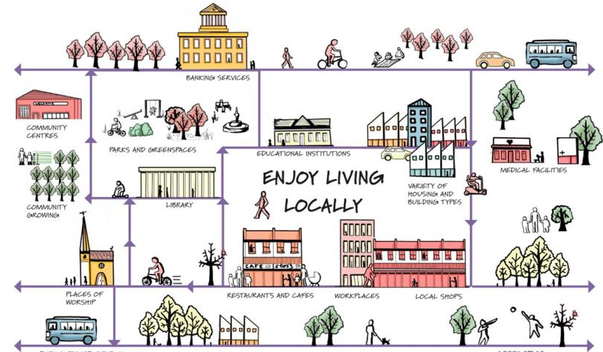

5.4 UTILITIES

Solid Water Management and Recycling
The Village of Coleman contracts with GFL to provide residential waste for direct disposal and recycling. Commercial waste disposal is the individual responsibility of the business owner.

Communication and Power Facilities
Electricity and Natural Gas is provided to the village by Wisconsin Public Service. Telephone and cable are provided by multiple different vendors.
Page 26
Sanitary Sewer Service
The Village of Coleman owns and operates a sewage treatment facility located at 718 Business 141, just south of Peshtigo River and east of Business 141. The facility was constructed in 1981 and has a current flow capacity of 275,000 gallons per day (gpd). The villages of Coleman and Pound entered into a new 40-year agreement in 2025 for shared capacity of sewer services; Coleman owns and operates the facility and has 80% of the capacity (220,000 gpd) and the Village of Pound purchases 20% of the capacity (55,000 gpd) the actual amounts purchased by the Village of Pound are calculated annually and are based on actual percentage of capacity used, not a flat percentage. Based on past flow rates, the Village of Pound uses anywhere between 20% and 27% of the system capacity on a yearly basis. The intergovernmental agreement specifies conditions and requirements for explanation, use, and operations.
Developed sections of the village have sewer service and new development is required to connect to the sewer system. Based on average daily flow rates the sewer system is nearing capacity, and periodically exceeds design flows depending on the time of year, typically due to groundwater intrusion into the existing pipes.
It is recommended the Village of Coleman continue to monitor the conditions and agreements with the Village of Pound. Coordination of land use policy and sewer system utilization will need to be discussed due to capacity limitations. Infrastructure replacement should also be continued part of system operations, efficiencies, and budgeting.

Public Water Supply
The Village of Coleman owns and operated its own water system. The water system was totally reconstructed in 1998-1999 as the old water main system developed in the 1970’s was under-sized and contained a number of breaks. The new water main construction consisted of 6500 feet if 12’ diameter water main, 2850 feet of 8’ water main, and 1350 feet of 6’ water main with appurtenances. The water main routes were planned in a manner that can serve both the existing and new development, and the system was looped together for increase efficiency and quality. In addition, a 300,000-gallon water storage tank replaces a 100,000-gallon tank, thereby tripling the storage capacity, increasing flow and pressure, and decreasing fire insurance rates. The village also operates two wells to supply the system.

Stormwater Management
The Village has a few areas that are serviced with storm sewer, but most of the stormwater is managed on the surface through curb and gutter or with an open ditch system.

5.5 UTILITY AND COMMUNITY FACILITIES PROGRAMS

Recycling Grant – The Wisconsin Recycling Grant Program provides funding primarily to Responsible Units—such as cities, towns, villages, counties, tribes, or solid waste management systems—to support residential recycling and yard waste programs. The Basic Recycling Grant helps cover costs like program planning, collection, outreach, staff wages, and related expenses for households with one to four units.

Page 27
Wisconsin Clean Water Fund Program (CWFP) - The Wisconsin Clean Water Fund Program (CWFP) is a state-administered financial assistance program that provides low-interest loans and principal forgiveness to municipalities for publicly owned wastewater and stormwater infrastructure projects. These projects must be necessary to achieve or maintain compliance with federal and state regulations, such as Wisconsin Pollutant Discharge Elimination System (WPDES) permits. The CWFP supports a range of initiatives, including wastewater treatment upgrades, stormwater management, and the removal of emerging contaminants like per- and polyfluoroalkyl substances (PFAS). The program offers fixed-interest loans with terms typically up to 20 years, and in some cases, up to 30 years, depending on the project's useful life. Additionally, municipalities with median household incomes below 80% of the state average may be eligible for principal forgiveness, reducing the overall loan repayment burden.

Focus on Energy – Focus on Energy is Wisconsin’s energy efficiency and renewable energy program that provides municipalities with financial incentives and technical support to reduce energy consumption and lower operational costs. Municipal governments can access rebates for upgrading lighting, HVAC systems, water treatment equipment, and other energy-intensive infrastructure. The program also assists with implementing renewable energy projects like solar installations. By partnering with Focus on Energy, municipalities benefit from expert guidance, helping them identify cost-effective energy-saving measures that improve sustainability and comply with environmental goals. These incentives help local governments stretch their budgets while reducing greenhouse gas emissions and promoting community resilience.

Rural Development - USDA Rural Development offers several programs to support rural communities by funding essential community facilities and utility projects. Key programs include the Community Facilities Direct Loan & Grant Program and the Guaranteed Loan Program, which help build or improve facilities like fire stations, healthcare centers, and public works buildings. The Emergency Community Water Assistance Grants provide funds to repair or replace water systems during emergencies. Additionally, the Rural Economic Development Loan & Grant Program and the Intermediary Relending Program support economic growth by providing low-interest loans to local utilities and lenders, which in turn fund local businesses and job creation. These programs enhance infrastructure, promote economic development, and improve quality of life in rural Wisconsin.

Page 28

CHAPTER 6
ECONOMIC DEVELOPMENT

The condition of the local economy directly influences local growth and development, and therefore must be considered when planning for a community’s future. Employment patterns and economic trends generally occur on a regional scale. Oftentimes residents of one community work in another. Similarly changes in a major industry can impact jobs and growth far beyond the community where the business is physically located. It is therefore important to understand a local community’s economy in light of its regional context. The following section provides a brief overview of the economy in the Village of Coleman, in terms of key economic sectors and the regional labor force. A more specific description of employment trends, major local employers or industries, and where most residents of the Village of Coleman’s work is included. Potential economic development opportunities and/or issues regarding the local economy are also identified.

Issues
Business – A need for more business; such as restaurants, gas stations, shops/stores, etc.

6.1 ECONOMIC DEVELOPMENT GOALS & OBJECTIVES
- Goal: Direct commercial and industrial growth to appropriate locations.
  - Objectives:
    - Direct future commercial growth along Main Street and Business 141.
    - Direct future industrial growth to the Village industrial park.
  - Action:
    - Develop signage, landscaping, and other requirements to distinguish the industrial park from surrounding uses.

6.2 ECONOMIC DEVELOPMENT POLICIES AND RECOMMENDATIONS
- Highway corridor development shall be directed to designated planned commercial areas and address building signage, lighting, service and land use standards.
- Economic development opportunities, which require public water and sanitary sewer services, shall be directed to areas which can provide public utilities.
- Work with Marinette County Economic Development Corporation to utilize existing resources to achieve community goals and objectives with regard to economic development
- Economic development efforts that strengthen and diversify the existing economic base will be pursued before time consuming and often expensive business recruitment efforts are taken
- Specifically permit the type, intensity, and location of industrial development in such a way as to foster a diversified economic base, while not being detrimental to the aesthetics and the quality of life through appropriate implementation tool and adherence to proper planning principals.

Page 29
6.3 LABOR FORCE & EMPLOYMENT CHARACTERISTICS

Table 9 - Employment Percentages Per Sector
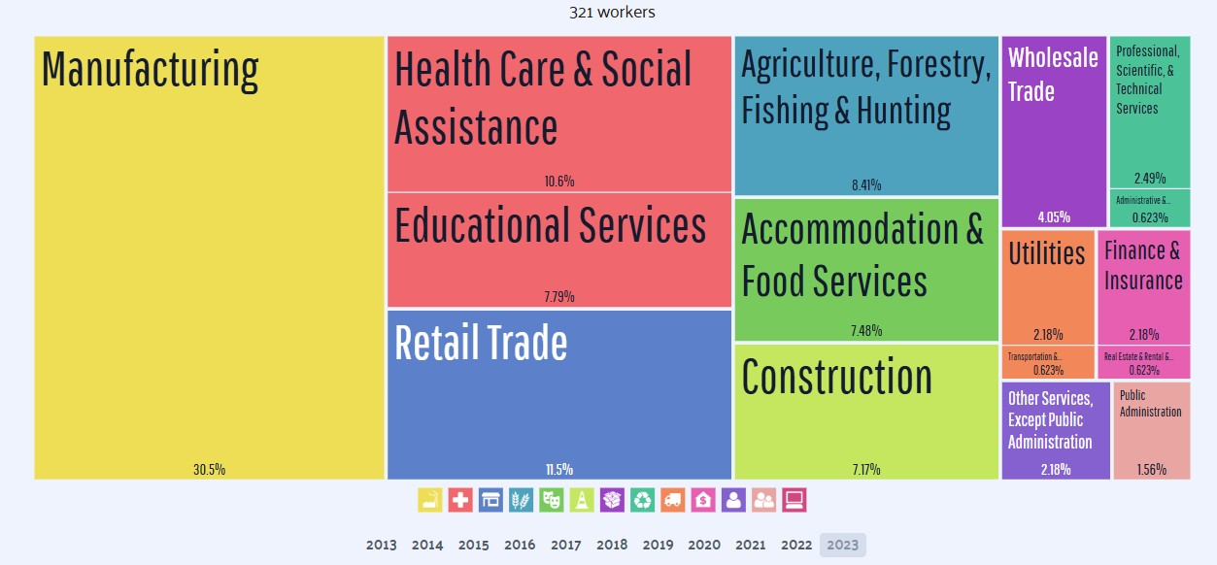
Source: Census Bureau ACS 5-year Estimate.

From 2022 to 2023, employment in Coleman, WI grew at a rate of 9.93% from 292 employees to 321 employees. The most common employment sector for those who live in Coleman are manufacturing, retail trade, and health care & social assistance. The table shows the breakdown of the primary industries for the resident of Coleman, though some may live in Coleman and work somewhere else. Census data is tagged to a residential address, not a work address. The mean transportation time to work for residents in the Village of Coleman is 22.2 minutes.
To see Marinette Counties 2025 Workforce Profile please visit https://www.jobcenterofwisconsin.com/wisconomy/wits_info/downloads/CP/marinette_profile.pdf

6.4 EDUCATION AND INCOME LEVELS
The Village of Coleman has a median household income level of $49,545 which is at least 80% of Marinette County’s median household income ($63,401) and approximately 2/3 of what the State of Wisconsin median household income ($75,670).

Page 30
Table 10 – Household Income
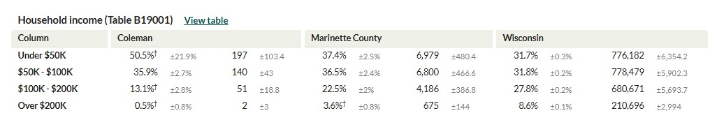
U.S. Census Bureau (2023). American Community Survey 5-year estimates. Retrieved from Census Reporter Profile page for Coleman village, Marinette County, WI <http://censusreporter.org/profiles/06000US5507516250-coleman-village-marinette-county-wi/>

91.6 % of residents of the Village of Coleman are a high school graduate or higher, and of the population 19% has a bachelor’s degree or higher. The table is based on residents 25 years and older.

Table 11 – Population by Education
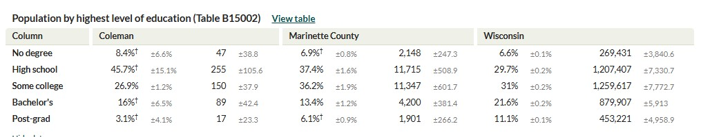
U.S. Census Bureau (2023). American Community Survey 5-year estimates. Retrieved from Census Reporter Profile page for Coleman village, Marinette County, WI <http://censusreporter.org/profiles/06000US5507516250-coleman-village-marinette-county-wi/>

6.5 ECONOMIC DEVELOPMENT PROGRAMS

Rural Development - USDA Rural Development offers several programs to support rural communities by funding essential community facilities and utility projects. Key programs include the Community Facilities Direct Loan & Grant Program and the Guaranteed Loan Program, which help build or improve facilities like fire stations, healthcare centers, and public works buildings. The Emergency Community Water Assistance Grants provide funds to repair or replace water systems during emergencies. Additionally, the Rural Economic Development Loan & Grant Program and the Intermediary Relending Program support economic growth by providing low-interest loans to local utilities and lenders, which in turn fund local businesses and job creation. These programs enhance infrastructure, promote economic development, and improve quality of life in rural Wisconsin.

Page 31
CHAPTER 7
LAND USE

Land use is a means of broadly classifying different types of activities relating to how land is used. The
type, location, density, and geographic extent of developed and undeveloped lands influence community
character, quality of life, public service needs (e.g., roads, utilities, parks, emergency services), tax base,
and availability of jobs throughout the Village. The land use pattern in the Village of Coleman consists
mostly of residential development.
A primary function of this land use element is to help guide future land use in a way that is compatible,
desirable, and accepted by the local community. This requires the consideration of a range of ideas and
opinions relative to land use, property rights, and community values. The community can effectively
manage land use through sensible land use controls and policies. Because land use is a people-oriented
process, personal opinions, desires, and attitudes, and legal and political considerations all have land use
impacts.
The Village of Coleman is located directly south of the Village of Pound and surrounded by the Town of Pound. With its mix of commercial business, schools, and churches, it functions as a service center to these surrounding communities.
Issues
Availability of land within the Village of Coleman

7.1 LAND USE GOALS & OBJECTIVES
- Goal: Preserve and enhance the small-town character of the Village of Coleman.
  - Objective:
    - Support the preservation of its small-town character.
  - Action:
    - Identify those aspects of the Village that best represent small town character, and strive to preserve them.

7.2 LAND USE POLICIES AND RECOMMENDATIONS
- All development proposals shall meet the goals and objectives of the established land use management areas, as identified within the land use element of the comprehensive plan.
- The village will encourage the concentration of higher density and intensity growth in and around areas that are adequately serviced by transportation facilities, public utilities, and community services and facilities.

Page 32
7.3 CURRENT LAND USE
Because the Village of Coleman has developed public services of water and sewer, it compacts the development within the villages’ 635 acres. The Village of Coleman has 206 acres of residential land use and within those 206 acres, has 373 parcels. Commercial property consists of 83 acres and 96 parcels and manufacturing land consists of 55 acres and 4 parcels. The Village of Coleman has 186 acres of agricultural land and 7 acres of agricultural forest and 70 acres of forest land. 28 acres located in the village are undeveloped. Commercial uses are concentrated along Business 141 and County Road B.

Table 12 – Parcel Characteristics

Source: Wisconsin Department of Revenue, Statement of Assessment 2021-2024
*Other includes swamp, waste, undeveloped, and other land.

7.4 Supply, Demand, and Price Trends of Land

Valuation
The equalized value of real estate property for municipalities is a vital component to the provisions of public facilities and services. The real property value in the Village of Coleman provides the tax revenues necessary to fund public facilities and service programs in the community. The following table (Table 13) presents the growth in equalized valuation of real estate for Coleman according to the Department of Revenue Division of State and Local Finance. The numbers do not include personal property items.
The equalized values of municipalities throughout Wisconsin have experienced significant increases in recent years. Typically, equalized values grow 2–6% annually, depending on the economy, inflation, and property development. Between 2022 and 2024 those increases were between 8% to 14% increases in equalized value from year to year in the state of Wisconsin. The increases were driven by multiple factors. One, being a strong demand for homes and commercial properties which pushed market values up. Another being an increased cost of materials and labor raised property values. Also, some localities hadn’t updated assessments for years, so equalized values caught up all at once.

Page 33
Table 13 – Equalized Valuation

Source: Wisconsin Department of Revenue, Statement of Assessment 2021-2024 *Other includes swamp, waste, undeveloped, and other land.

The Village of Coleman increased in valuation by $21,431,500, a total increase of 47.44% throughout the 4 years. Residential increased in valuation the most with $18,002,200, which accounted for 39.84% growth in those 4 years.

7.5 DEVELOPMENT REGULATIONS
A general description of existing land use controls and related issues pertaining to the Village of Coleman are presented within this section. For more information, the specific ordinance should be consulted. The Village of Coleman has developed a code of ordinances that regulate land use in the village. The village's land use legislation covers zoning, subdivision of land, shoreland-wetland zoning, floodplain zoning and annexation.

Zoning Code
The main development regulation that affects land use in the village is the zoning code. The zoning code arranges the village into eleven districts. Within each of these districts, the text of the zoning code specifies permitted land uses, conditional uses, allowed lot sizes, building heights and setbacks and any other additional requirements. The goal of the zoning code is to secure a reasonable development pattern by keeping similar and related uses together and separating dissimilar, unrelated and incompatible uses.
The Village of Coleman Zoning Code identifies the following eleven districts:
• R-1, Single Family Residential District
• R-2, Single-Family Residential District
• R-3, Multifamily Residential District
• R-4, Rural Development District
• B-1, General Commercial District
• B-2, Convenience Commercial District
• B-3, Highway Commercial District
• I-1, General Industrial District
• I-2, Special Use Industrial District
• Migrant Housing District
• C-1, Conservancy District

Page 34
Floodplain Zoning Ordinance
The purpose of the Village of Coleman Floodplain Zoning Ordinance is the same as the Marinette County ordinance. The Coleman Ordinance includes an official map and three floodplain districts including the Floodway District, Flood Fringe District and General Floodplain District. Areas regulated include lands within the village that would be inundated by a 100-year flood as designated by Federal Emergency Management Agency studies. Wisconsin Statutes 87.30 require villages to implement floodplain zoning.

Shoreland-Wetland Zoning
The Shoreland-Wetland District, as designated by the zoning ordinance, includes all wetlands in the village which are five acres or more and are shown on the wetland inventory map. The district also includes areas within 1,000 feet of the ordinary high-water mark of navigable lakes, ponds or flowages and within 300 feet of rivers, streams, or the landward side of a floodplain.

Subdivision of Land
Wisconsin Statutes 236.45, enables villages with an established planning agency to adopt ordinances governing subdivisions or other divisions of land. The general purpose of the ordinance is to promote the general welfare of the community, provide an orderly layout and use of land, prevent overcrowding, congestion and safety concerns and to generally encourage the most appropriate use of land throughout the village.

7.6 FUTURE LAND USE
According to section 66.1001 Wis. Stats., Comprehensive Planning, the Land Use Element of a comprehensive plan must specify the general location of future land uses by net density or other classifications. To address this requirement, the following preferred land use management area descriptions have been developed to allow the Village of Coleman the opportunity to promote the desired features of their respective communities. The Preferred Land Use management areas are simply designated areas of consistent character, use, and density that share similar goals and objectives for future use. The land use management areas are not zoning districts, and do not have the authority of zoning. However, they can be used to help guide land use decisions through a number of different implementation tools, such as land division, ordinances, and coordination with zoning regulations.

Page 35
Village of Coleman
General Plan Design

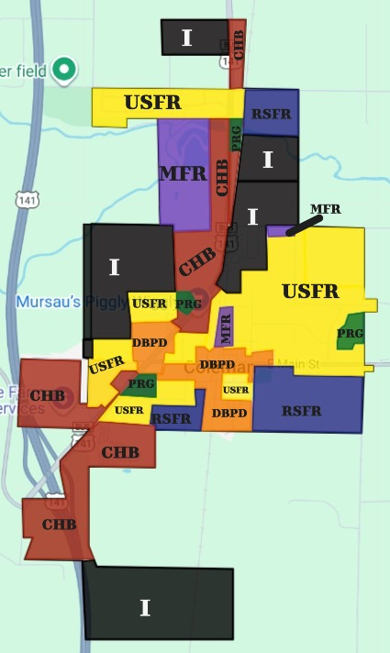

Urban Single-Family Residential (USFR)
This classification is intended to maintain and develop single-family residential areas consistent with the existing development, street network, and zoning pattern. The management area also envisions the potential expansion of public services in conjunction with market demands that conclude in a high development potential. Relatively affordable and available land will also draw development potential to the area.
Rural Single-Family Residential (RSFR)
This management area is intended to accommodate preferred locations of residential development on lots a little larger in size, which are located adjacent to or near major travel corridors in incorporated areas, recreation lands, and limited rural services. Development would primarily use private on-site waste disposal systems, and private wells as they do not have access to public services. A central idea behind the RSFS management area is to identify areas that have development potential where overall density could be decreased from the typical subdivision lot sizes.
Multi-Family Residential (MFR)
This classification is intended to provide for areas of higher density development, and to minimize the potential conflict that larger, higher density development typically creates when construction in low density, single-family areas. Multifamily uses are defined as a residential development with three or more units as part of a primary structure. The villages zoning ordinance already incorporates, and necessary language to address development regulations and conserve the high-density development with public services. The plan has identified the areas with existing multifamily development for such uses and designating a few more new parcels in the village for multifamily. As an overall use, multifamily is a very small percentage of the village.

Community and Highway Business (CHB)
This management area was developed to provide for areas of commercial development, concentrated primary primarily along the Business 141 corridor. In planning for the future, the Village of Coleman realizes a healthy downtown is good for the community and land use policy should coordinate potential uses and a policy so not to create economic development competition between interchange area and downtown but rather to complement both.

Downtown Business Planning District (DBPD)
This classification is intended to designate the general downtown area as a targeted development area for purposes of community identity and developing a place of destination. A vibrant downtown area will enhance the image of the village and create an identity to help stimulate economic development. Although the downtown area is a relatively small area, the downtown has substantial opportunity to maintain and revitalize its appeal based on the character of the area, many of the existing buildings, and general lack of over-development.
Page 36
7.7 LAND USE PROGRAMS
The developed Preferred Land Use Plan and Preferred Land Use Map will be utilized as the primary land use program within the Village of Coleman over the planning period.



Page 37
CHAPTER 8

INTERGOVERNMENTAL RELATIONS

This analysis presents an inventory of existing mechanisms that the Village of Coleman uses to coordinate with other units of government, including: Marinette County, adjacent towns, the school district, the State of Wisconsin and the Federal government. The purpose of this analysis is to identify the existing cooperative mechanisms and summarize the major challenges and issues regarding intergovernmental cooperation and regional planning, including:
• Opportunities to reduce or eliminate duplication of services;
• Incompatible goals, policies and development;
• Mechanisms for conflict resolution;
• Opportunities for joint planning and decision making.
Mechanisms for cooperation and coordination primarily take the form of intergovernmental agreements, leases and contracts, and regulatory authority. These can occur between the Village of Coleman and other local, regional, State or Federal entities. Following is a brief description of the various functional areas and services that require intergovernmental coordination at various levels.

Issues
No significant issues have been identified

8.1 INTERGOVERNMENTAL RELATIONS GOALS & OBJECTIVES
- Goal: Maintain and enhance mutually beneficial intergovernmental relationships with other units of government.
  - Objectives:
    - Pursue cooperative boundary agreements with neighboring communities to address annexation, expansion of public sewer and water services, and growth management between neighboring communities.
    - Improve cooperation and coordination with adjacent municipalities regarding long range planning and land use controls.
  - Action:
    - Keep up to date copies of agreements and work with the municipalities to renew these agreements as needed.

8.2 INTERGOVERNMENTAL RELATIONS POLICIES AND RECOMMENDATIONS
- Continue cooperative planning efforts with surrounding towns, villages, Marinette County, districts, associations, and service providers,
- Opportunities for sharing community staff or contracting out existing staff availability will be pursued should the opportunity arise.
- All community facilities, which have available capacity shall be considered for joint use with a neighboring community.
- Any and all intergovernmental agreements or arrangements shall be in writing, the statutory authority for such agreements identified.
Page 38
- Public Participation and information distribution which was used during the comprehensive planning process will be pursued for future community implementation and planning practices.
- Intergovernmental agreements shall be reviewed annually for their effectiveness and efficiency.
- A framework and/or standards for boundary negotiations and joint planning efforts with neighboring cities, towns, and villages shall be maintained.

Table 14 – Intergovernmental Arrangements

8.3 COOPERATIVE PRACTICES
Schools – The Village of Coleman works with the Coleman School District and Faith Christian School for sharing of services such as parks, gymnasiums, pavilions, and trail systems. Village of Coleman Police Department also works closely with the schools to be able to provide a safe, fast and reliable service when needed.
Marinette County – The County works with the Village of Coleman on multiple occasions. The county provides police services, tax services, county highway maintenance and improvements, and emergency management, along with many other services.
State and Federal Agencies – The villages’ relationship with the State of Wisconsin mainly involves state aids and administering of various state mandates and regulations. Some state agencies that work with the village include but not limited to the Wisconsin Department of Natural Resources (WDNR), Wisconsin Department of Transportation (WDOT), and Wisconsin Department of Revenue (WDOR). State agencies regulate certain activities such as access onto State roads, shoreland, floodplain and wetland zoning oversight, compliance with water quality standards, and managed forest tax credit programs. In Wisconsin, most federal programs are administered by the State, so the Village would be dealing with the responsible state agency with regard to federal programs and regulation.

Page 39
8.4 INTERGOVERNMENTAL RELATIONS PROGRAMS

66.0313 Law Enforcement; Mutual Assistance – Upon the request of any law enforcement agency, including county law enforcement agencies, personnel may assist the requesting agency within the latter’s jurisdiction. While acting in response to a request for assistance, the responders shall be deemed employees of the requesting agency. Refer to the Statute for further information.

61.34(2) Cooperation with Other Municipalities – A village board, on behalf of the village, may join with other villages or cities in a cooperative arrangement for executing any power or duty in order to attain a greater economy or efficiency, including joint employment of appointive officers and employees.

Office of Land Information Services, Municipal Boundary Review – Municipal Boundary Review regulates the transition of unincorporated areas to city or village status through municipal annexation, incorporation, consolidation, or by joint city-town-village activities involving cooperative boundary plans and agreements. Such agreements may change territorial boundaries and may provide for the sharing of municipal services. Staff members are available upon request to meet with local officials and citizens to discuss annexation, incorporation, consolidation, and cooperative boundary plans. Contact the Wisconsin Department of Administration, Office Land Information Services for further information.

League of Wisconsin Municipalities – The League of Wisconsin Municipalities is a nonprofit, nonpartisan organization that represents Wisconsin’s cities and villages. Founded in 1898, the League supports over 600 municipalities by advocating for local government interests at the state level, offering legal guidance, and providing training and resources to municipal officials. Its work focuses on protecting local authority, improving municipal funding, and addressing challenges in areas such as land use, public safety, infrastructure, and governance. Through publications, conferences, and a statewide network, the League helps strengthen local governments and enhance the quality of life in Wisconsin communities.

Bay Lake Regional Planning - The Bay-Lake Regional Planning Commission (Bay-Lake RPC) is a multi-service governmental planning agency serving eight counties in northeastern Wisconsin (Brown, Door, Florence, Kewaunee, Manitowoc, Marinette, Oconto, and Sheboygan). Established in 1972 under state statute as the official area-wide planning body for that region, its role is advisory: it provides planning, technical, and coordination services to over 185 local government units in its region. The Commission’s work spans a range of functions, including community development and comprehensive planning, transportation and multimodal planning, environmental and coastal resource planning, hazard mitigation, economic development, and mapping and visualization using GIS tools. With over 400 miles of coastline along Lake Michigan and Green Bay and 12 major watersheds in its region, Bay-Lake RPC plays a critical role in coordinating sustainable growth, protecting natural resources, and helping member municipalities access grants and technical expertise.

Page 40
CHAPTER 9
IMPLEMENTATION

The primary reason a community prepares a comprehensive plan is to establish a framework to influence
decisions regarding management of growth and regulation of development to maintain the desired community
character, and to set priorities for public expenditures. To be effective, this plan should be actively used as a
tool to guide decisions concerning:
• The implementation and enforcement of regulatory ordinances based on the goals and objectives identified
in this plan.
• The development of programs and support systems that further the goals and objectives set forth in this
plan.
• The implementation of specific community improvements as identified in the comprehensive plan.
• The establishment and support of a continued planning process providing for periodic review and updates
to this plan and other land use control measures.

Issues
No significant issues have been identified

9.1 IMPLEMENTATION GOALS & OBJECTIVES

- Goal: Promote consistency between plan recommendations, ordinances, and other land use regulations.
  - Objective:
    - Encourage citizen participation in order to increase local input in the decision-making process.
    - Update the implementation tools, such as the Zoning and Subdivision ordinances as needed so as to comply with the Comprehensive Plan.
  - Action:
    - Conduct a comprehensive review of existing zoning and subdivision ordinances at least every few years to ensure alignment with the Comprehensive Plan.
    - Develop a streamlined process for ordinance amendments that includes public input, interdepartmental coordination, and legal review to ensure transparency and consistency.
- Goal: Update the Comprehensive Plan on a regular schedule to ensure the plan remains a useful tool for growth and development decisions.
  - Objective:
    - Integrate updated data and policy best practices into each revision.
    - Conduct a formal review and update of the Comprehensive Plan every 10 years.
    - Integrate updated data and policy best practices into each revision.
  - Action:
    - Allocate budget and staff resources specifically for Comprehensive Plan updates.
    - Publish all updates online with interactive maps and summaries for public access.
    - Present updates in public meetings and hearings prior to adoption.
    - Incorporate current census data, land use trends, and environmental assessments.

Page 41
9.2 IMPLEMENTATION POLICIES AND RECOMMENDATIONS

1. The Village Board should adopt the plan and use it as guide for decision making.
2. The Plan Commission should become knowledgeable of the plan and use it to justify recommendations to
the Village Board on development issues.
3. The Village should encourage citizen awareness of the Comprehensive Plan. It is also important that area
developers are aware of the plan.
4. Village staff should incorporate goals, objectives and actions of the plan into annual work plans and budgets.
5. The Village should review its Zoning Ordinance to ensure consistency between the two documents and
incorporate any needed changes.
6. The Village should periodically review the Comprehensive plan and update the documents in ten years.

9.3 IMPLEMENTATION TOOLS

Having the appropriate tools to implement the recommendations in this comprehensive plan is critical. The
most common implementation tools are the villages official controls or regulatory codes. In particular, the
zoning ordinance and subdivision (or land division) regulations comprise the principal regulatory devices used to protect existing development and guide future growth and development as identified in this comprehensive
plan. There are also non-regulatory approaches to implementing the comprehensive plan; these generally involve decisions about how the community will spend its limited funding resources on capital improvements
and staffing.

Zoning Ordinance and Map
Zoning is used to manage and control how land is used and developed. Zoning ordinances typically establish detailed regulations concerning how land may be developed, including setbacks, the density or intensity of development, and the height and bulk of building and other structures. The general purpose of zoning is to minimize undesirable side effects resulting from development by segregating and/or buffering incompatible uses and by maintaining standards that ensure development will not negatively impact the community’s character or environment. The establishment of zoning districts and the zoning map indicates where specific types of development can and should be located. Zoning districts shown on the zoning map should be coordinated with the land use plan and map. While the zoning map and land use map do not need to directly match at the time the land use map is adopted, the intent is that the land use map will serve as a guide indicating how the property should eventually be zoned. Therefore, indiscriminate zoning changes may result in weakening of the comprehensive plan. In fact, changes to zoning district boundaries should only be made if they are consistent with the adopted land use map.

However, there may be situations where changing the zoning district boundary makes sense and is in the best
interest of the community. If changing the zoning would result in a conflict with the future land use map, the
land use map should also be changed. However, the future land use map should only be changed if it does not
accurately reflect the community’s desired land use pattern. Achieving consistency between zoning and land
use designation is also discussed in the Land Use Element.
As discussed, the comprehensive plan (and future land use map) should be periodically reviewed and
updated to adjust for unforeseen changes or events that were not considered at the time the initial plan and
land use map was developed.
The Village Board makes the final decisions regarding changes to the content of the zoning ordinance and the
district map. These decisions are preceded by public hearings and recommendations of the plan commission.

Page 42
Subdivision (Land Division) Ordinance
Subdivision regulations serve as an important function by ensuring the orderly development of unplatted and/or undeveloped land. These regulations may set forth reasonable regulations for lot sizes, road access, street design, public utilities, storm water drainage, parks and open space, and other improvements necessary to ensure that new development will be an asset. The Board makes the final decisions on the content of the subdivision ordinance. These decisions are preceded by public hearings and recommendations of the plan commission.

Historic Preservation Ordinances
Wisconsin State Statues provide a village board in the exercise of its zoning and police powers for the purpose of promoting the health, safety, and general welfare of the community and of the state, may regulate any place, structure or object with special character, historic interest, aesthetic interest or other significant value for the purpose of preservation.

Design Review Ordinances
Design Review is an option for a community who is concerned with overall community aesthetics and character. Typically design review ordinances are built using terms and conditions that are built from community involvement, or a photo-based design vocabulary so people can see what’s meant when the village talks about community character. The village should consider the use of design review regulations. The USH 141 corridor and the downtown area would be most applicable concept.
Design Review regulations are often used by a community to encourage growth and development which is consistent with maintaining a specific design character, to protect and enhance the community appeal for citizen and visitor use, ad enjoyment and protection against development which uses standard urban and suburban approaches. The idea is to safeguard property values and promote high-quality commercial, multifamily, and industrial development by minimizing highway strip commercial development and to encourage well designed highway clustered commercial development.

Sign Regulations
The village has adopted sign regulations as regulated in Article VII, section 305-46, zoning chapter in the Village Code. It is recommended the village assess the development identity signage by use of the village to promote and market the village and its public features. The village should assess the size requirements and regulations in section 305-48, signs in businesses and industrial districts. The assessment should be coordinated with anticipated future downtown and economic development planning, and as part of the potential design review and consideration of building development and modification in the downtown area.

Sanitary Codes and Public Sewer Services
The Village’s public sewer system is nearing capacity should be reviewed for its ability to serve the villages of Coleman and Pound into the future. The system assessment should also include the current shared service agreement with the Village of Pound, as well as the potential future service areas outside the village borders, such as the 141-highway interchange area and potential planned industrial site areas.

Building Codes
The State of Wisconsin has a uniform dwelling code which must be followed for the construction and
inspection of all one and two-family dwellings. Local communities have certain responsibilities for
enforcement of this code. The Village regulates the compliance of building codes.

Page 43
Housing Codes
The Village of Coleman’s Zoning Ordinance does not address minimum standards for basic equipment,
lighting, ventilation, heating, electrical service, or maintenance guidelines. These standards are enforced
through the State of Wisconsin's Uniform Dwelling Code and should be consistent with this plan. An
inspector for the Village ensures compliance with the Uniform Dwelling Code.

Official Maps
Cities, villages, and towns may adopt official maps. These maps, adopted by ordinance or resolution, may show existing and planned streets, highways, historic districts, parkways, parks, playgrounds, railroad right-of-way, waterways, and public transit facilities. The map also may include a waterway only if it is included in a comprehensive surface water drainage plan. No building permit may be issued to construct or enlarge any building within the limits of these mapped areas except pursuant to conditions identified in the law.
Official maps are not used frequently because few communities plan anything but major thoroughfares
and parks in detail in advance of the imminent development of a neighborhood.

Capital Improvement Plan (CIP)
This is an ongoing financial planning program that allows local communities to plan ahead for capital expenditures and minimize unplanned expenses. A capital improvement plan consists of a list of proposed projects according to a schedule of priorities over a four-to-six-year period. It identifies needed public improvements, estimates their costs, and identifies financing methods and sources.
Public improvements or expenditures typically considered in a CIP include:
• Public buildings (i.e., fire and police stations)
• Park and trail acquisition and development
• Roads and highways (maintenance and new construction/paving)
• Utility system construction/expansion, treatment plants, water towers, wells, etc.
• Joint school and other community development projects
• Fire and police protection equipment
A CIP is simply a method of planning for and scheduling expenditures for public improvements over a period of
several years in order to maximize the use of limited public funds. Each year the CIP should be reviewed and
extended one year to compensate for the previous year that was completed. This keeps the improvement
program current and allows for modifications to meet the community’s changing needs.

9.4 PLAN AMENDMENTS

Periodic amendments can be made to this Plan. Amendments are generally defined as minor changes, such as
slight changes to the text or maps. Frequent changes to accommodate specific development proposals should
be avoided.
Criteria to consider when reviewing plan changes are as follows:
1. The change is consistent with the overall goals and objectives of the Village of Coleman Comprehensive Plan.
2. The change does not create an adverse impact on public facilities and services that cannot be mitigated.
3. Development resulting from the change does not create an undue impact on surrounding properties. Such
development should be consistent with the physical character of the surrounding neighborhood or would
upgrade and improve its viability.
4. The change allows a more viable transition to the planned uses on adjacent properties than the current land
use.
Page 44
5. The change does not have a significant adverse impact on the natural environment including trees, slopes
and groundwater, or the impact could be mitigated by improvements on the site or in the same vicinity.
6. There is a change in Village actions or neighborhood characteristics that would justify a change.
7. The change corrects an error made in the original plan.
8. There is a community or regional need identified in the comprehensive plan for the proposed land use or
service.
9. The change does not adversely impact any landmarks or other historically significant structures or properties unless mitigated through relocation, commemoration or dedication.

Plan Updates
According to the State comprehensive planning law, comprehensive plans must be updated at least once every ten years. As opposed to the more routine amendments described above, plan updates often involve re-writing of whole sections of the plan document and significant changes to supporting maps. A plan update should include a thorough examination of the community’s goals and objectives based on an analysis of current growth trends and major changes that have occurred since the plan was initially adopted or last amended. Plan updates must be formally adopted following the same procedure described above for initial plan adoption.

9.5 MEASURING PLAN PROGRESS

To measure the progress towards meeting these goals, objectives, actions and projects, a variety of actions
need to take place. In some cases, the task to measure plan progress is as simple as determining if any action
was taken or not. Objectives could be categorized by the time it may take to accomplish them, generally short-term, or 1 to 5 years, mid-term, or 6 to 10 years, and long-term or 10 years or more. In other cases, some of
the actions and projects identified in the plan are continuous or on-going; these should also be monitored to
measure the plan’s overall success. The development of a strategic plan could provide guidance to the Village
on when specific actions are to be initiated. Based on such a plan, measures of progress in achieving
implementation of the comprehensive plan can be examined.

It is recommended that a periodic “Plan Status” report be prepared to summarize the progress toward
implementation. This report might be jointly developed by various village departments, as related to their
involvement in the implementation of the goals, objectives, actions, and projects developed within this plan.
Ultimately, the success of the planning process will be measured by the future quality of life and prosperity
experienced by both residents and visitors to Coleman.

9.6 IMPLEMENTATION PROGRAMS

Implementation programs applicable to this element of the comprehensive plan are primarily those powers and programs granted to the village through the Wisconsin Statutes. Statutes which allow communities to enact land use controls and make land use planning decisions are the programs that are used to make implementation a reality of this comprehensive plan, its goals, and its policies.

Page 45

