Village of Coleman
Community Survey 2025

- In general, how satisfied are you with the Village of Coleman as a place to live?

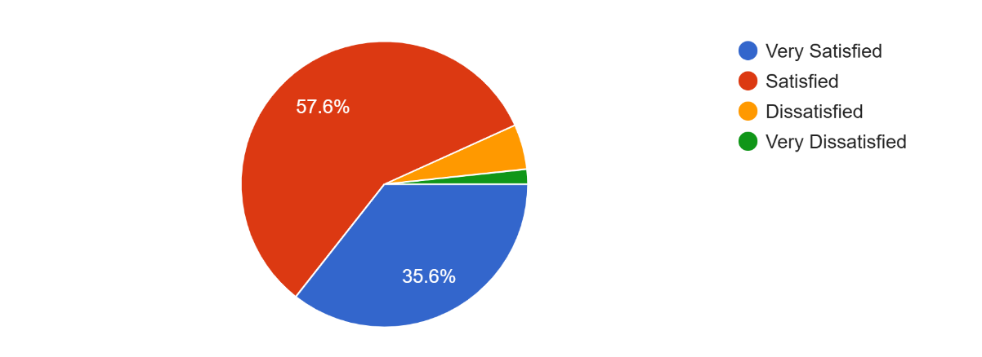

5.1%
1.7%

- Please check each box that pertains to why you choose to live in the Village of Coleman.

- Rate the overall quality of life in the Village of Coleman. 5= Excellent. 1= Poor

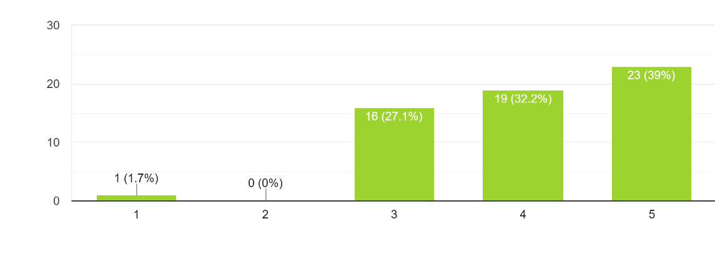

Ratings

- Check two things you would like to improve in the Village of Coleman. Any specific improvements you would like to see please select other and write in what improvement you would like to see. (59 responses)

- Annually, volunteer and non-profit events like the firefighter’s picnic, village-wide rummage sale, Spring/Fall clean-up, Music in the Park, etc. take place in the village. Would you like to see more community events in the village?

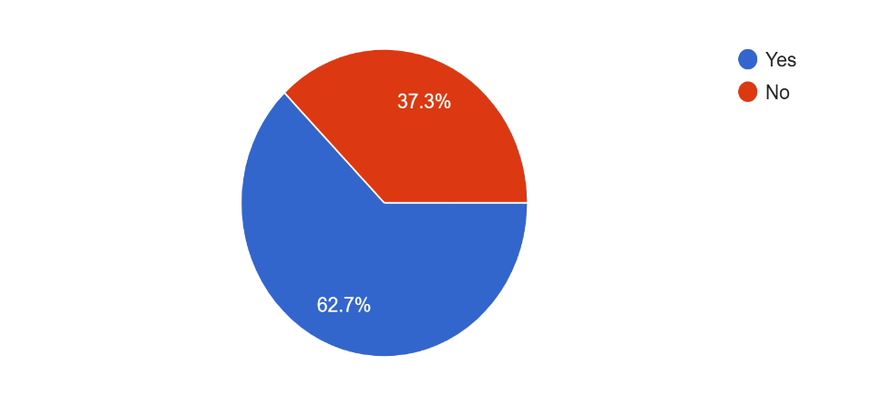

- If you answered “yes” to the question above, what kinds of community events would you like to see in the village?

Tree lighting ceremony, farmers markets (Fall/Christmas), movie in the park, music in the park, horseshoe tournament, hot cocoa contest with winter festival, food truck events, bike ride, co-ed softball league, roadside leaf/brush pick up, car show, scavenger hunt/road rally, block parties, bingo in the pavilion.

- What are the most effective ways to receive information from the Village of Coleman?

- Have you visited the Village of Coleman website?
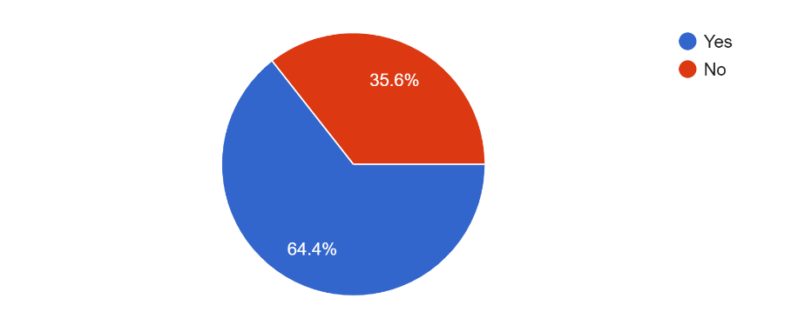

- Do you own or rent your residence?
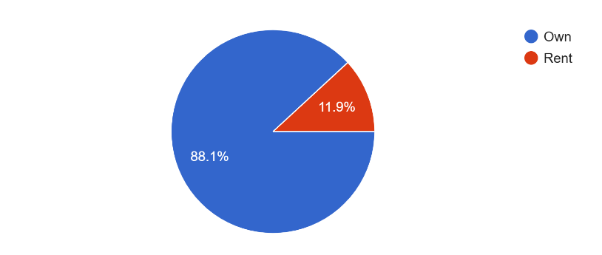

- Rate the overall quality and appearance of housing in the Village of Coleman.
5=Excellent, 1=Poor

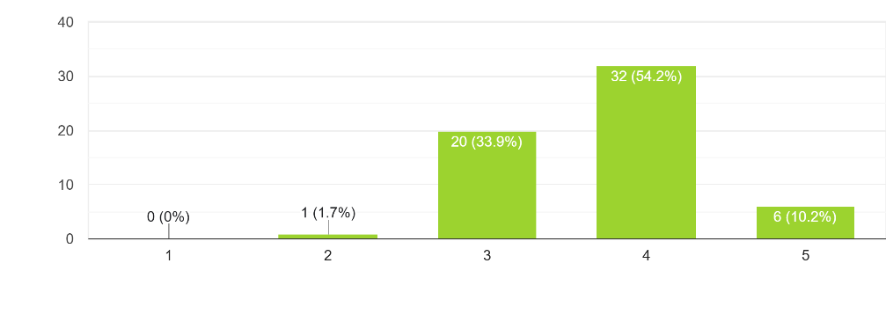



- To what extent do you favor new residential development in the Village of Coleman?
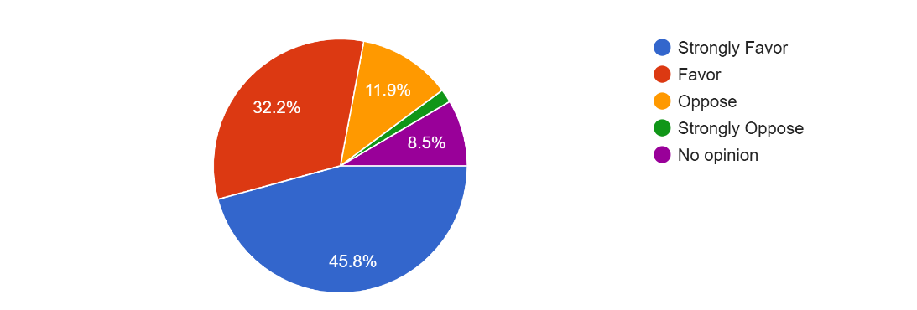
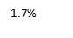

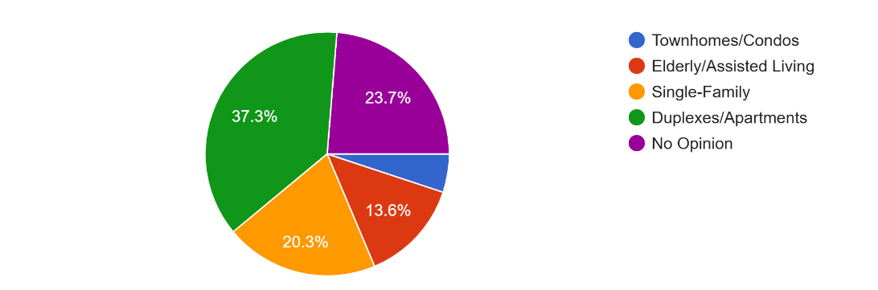
- What, if any, types of residential dwellings does the Village of Coleman need more of?
5.1%

- Rate the overall condition of roads in the Village of Coleman.
5=Excellent, 1=Poor

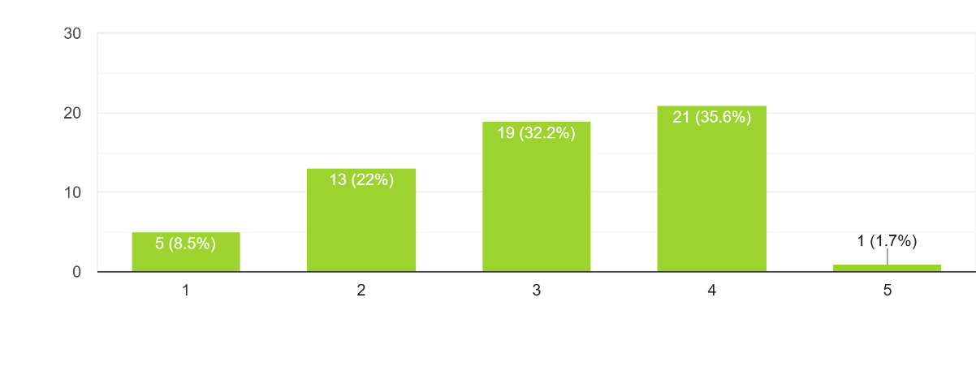

Ratings
- The Village of Coleman is a safe community for bicyclists and pedestrians.

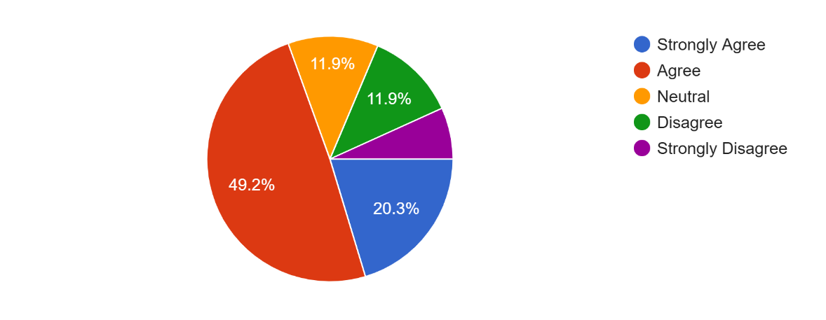

6.8%

- How concerned are you with the volume & flow of traffic in the Village of Coleman?

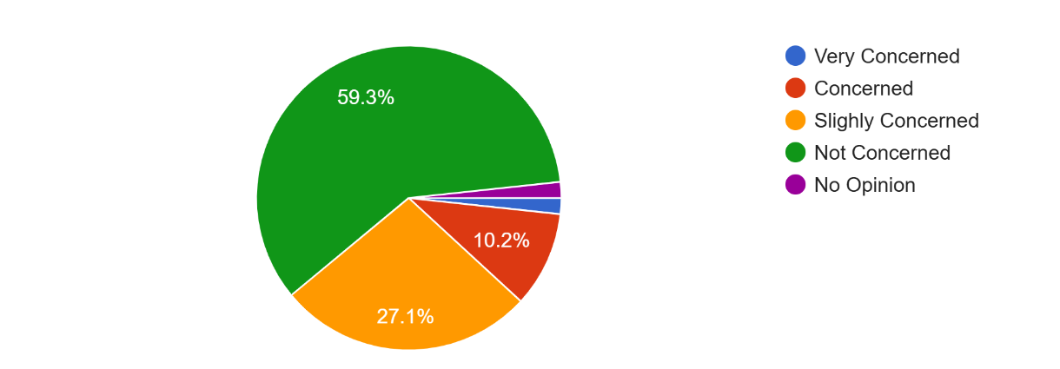
1.7%
1.7%
- To what degree should the Village of Coleman consider and/or encourage the following services and facilities?
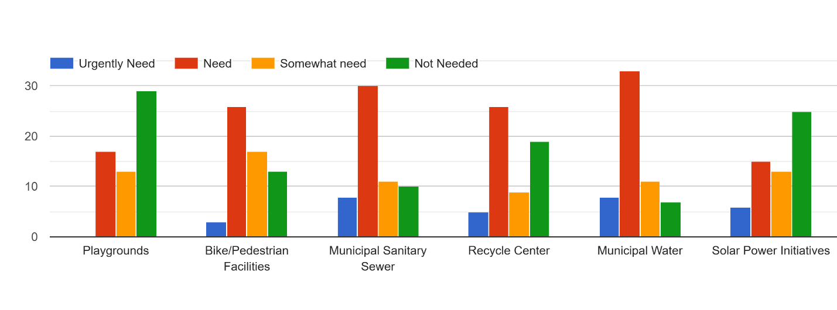

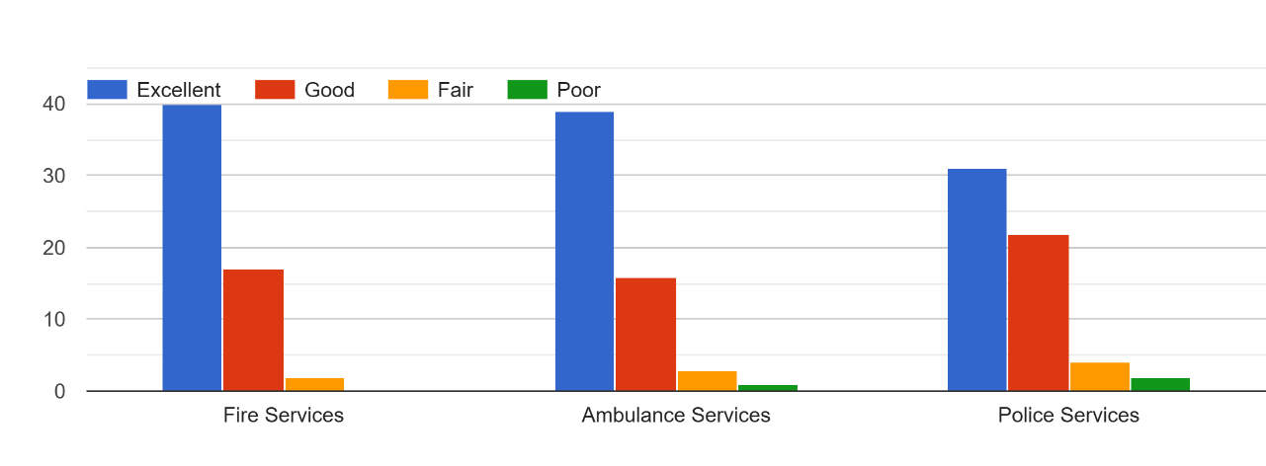
- How would you rate the quality of the following services?

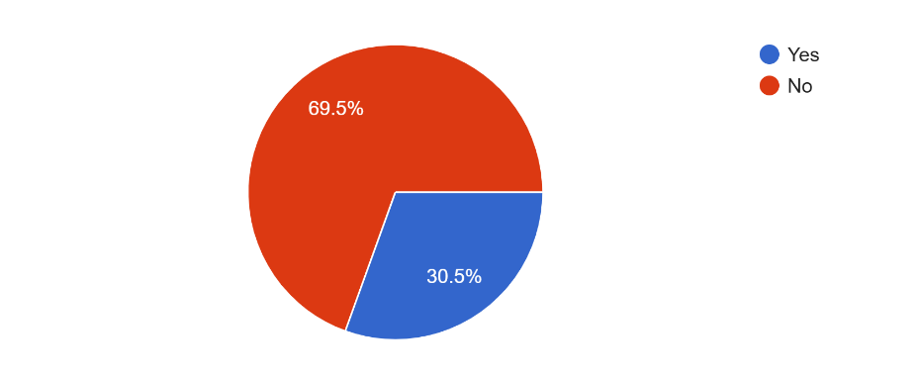
- Do you own an ATV or UTV?
- Overall, how would you describe your position with respect to ATV/UTV use on Village of Coleman roads?
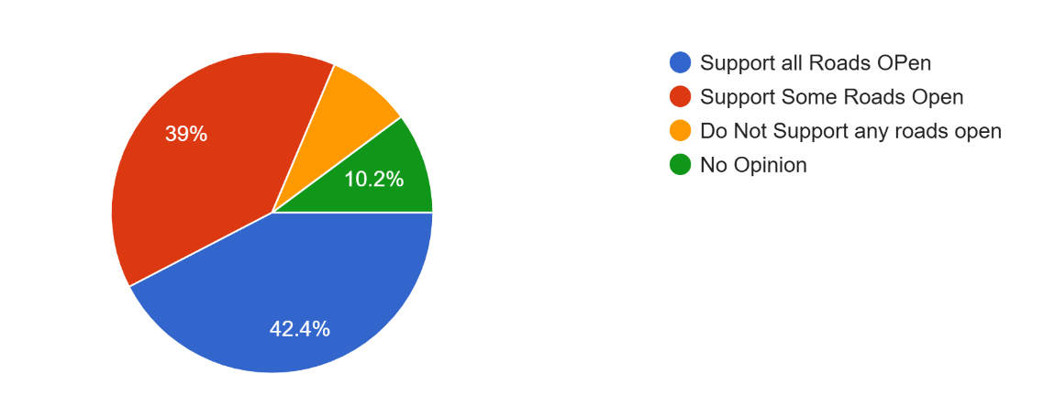
8.5%

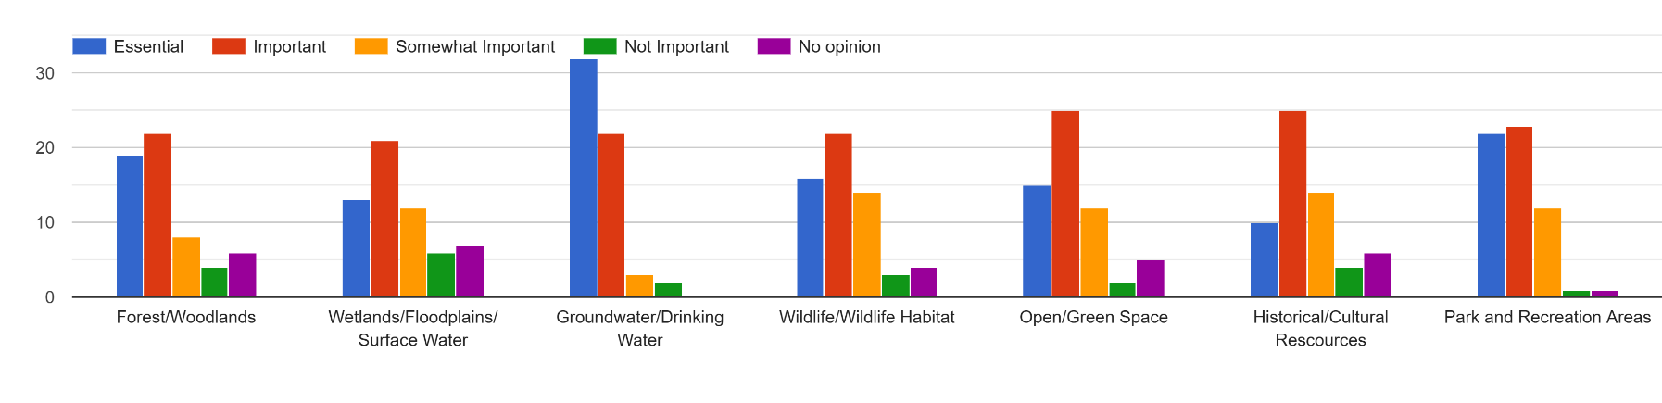
- How important are the following to protect and/or enhance in the Village of Coleman?

- New business development should be encouraged in the Village of Coleman.

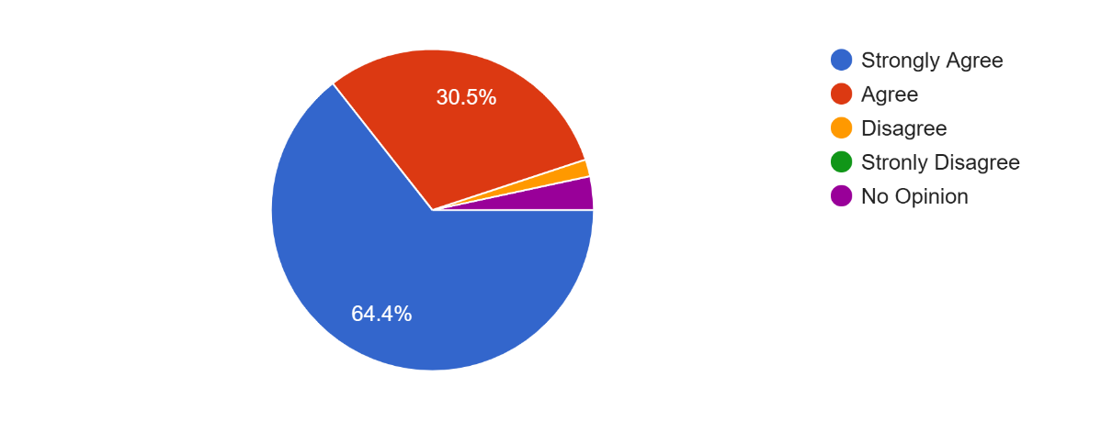
1.7%
3.4%
- What types of businesses would you like to see located in the Village of Coleman? (Written responses)
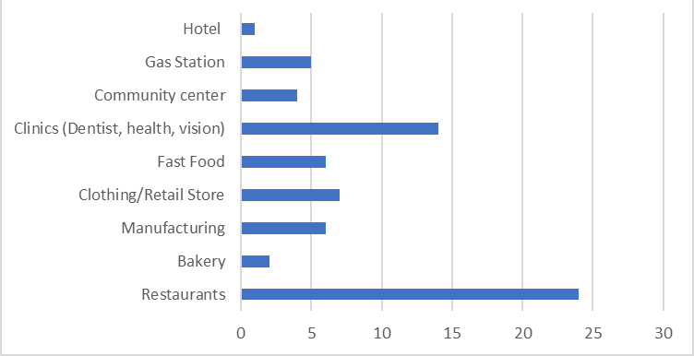

- Do you currently operate a home occupation business?
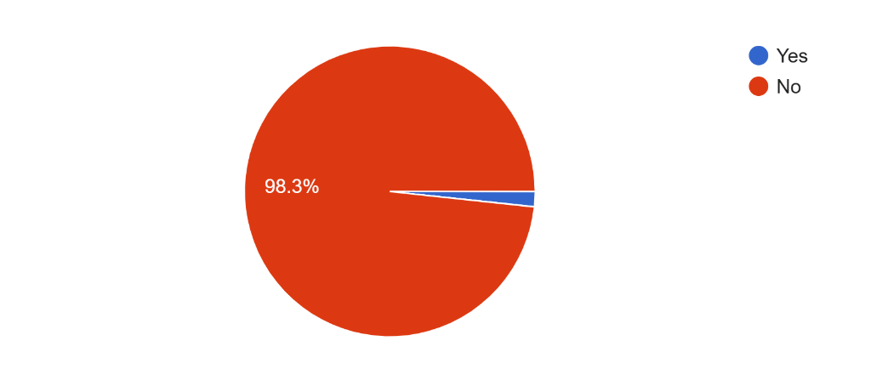
1.7%
- What, if any, land uses would you like to see grow or expand in the Village of Coleman?
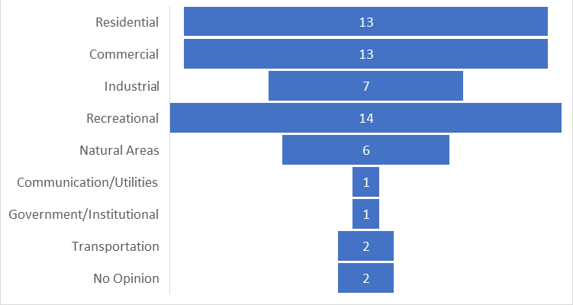

- What is your age?
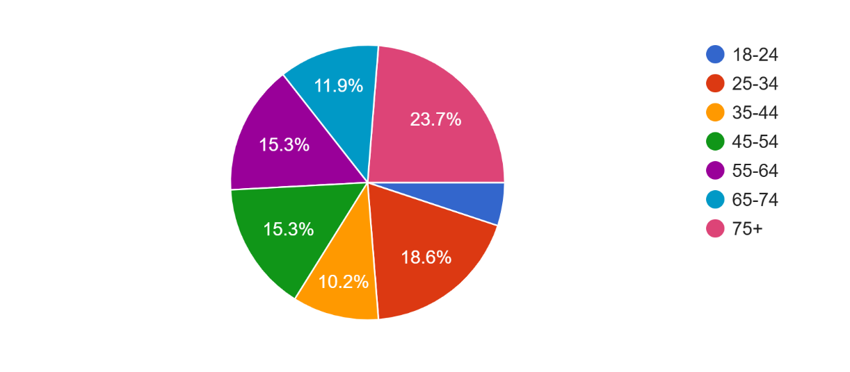
5.1%

- How long have you resided in the Village of Coleman?

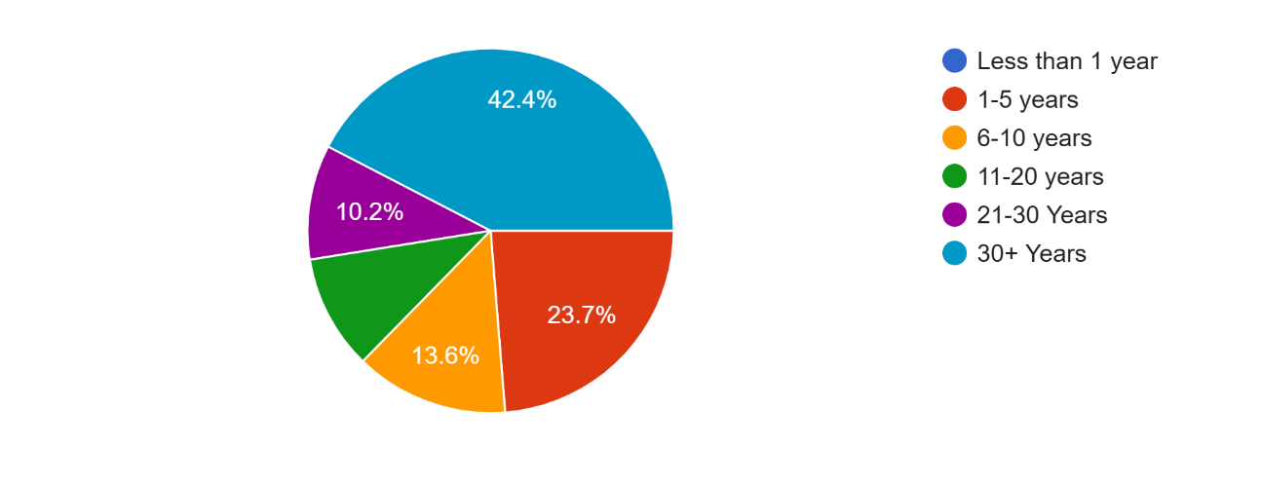
10.2%

- If you are employed, where is your primary place of employment?

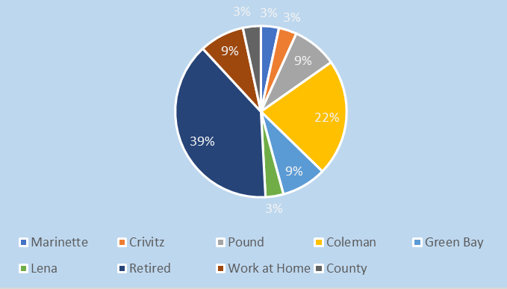

- How many children under the age of 18 years old live in your home?
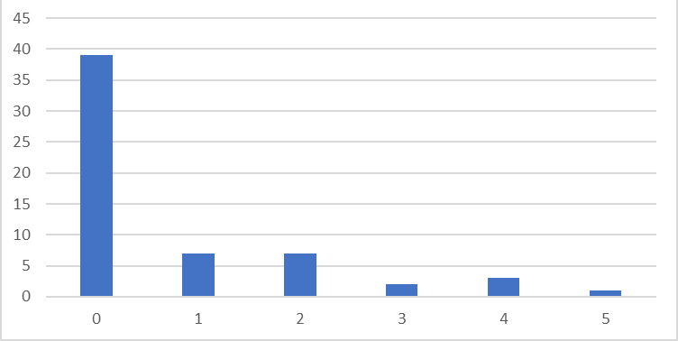
# of Children over 18

- How many people currently live in your household?
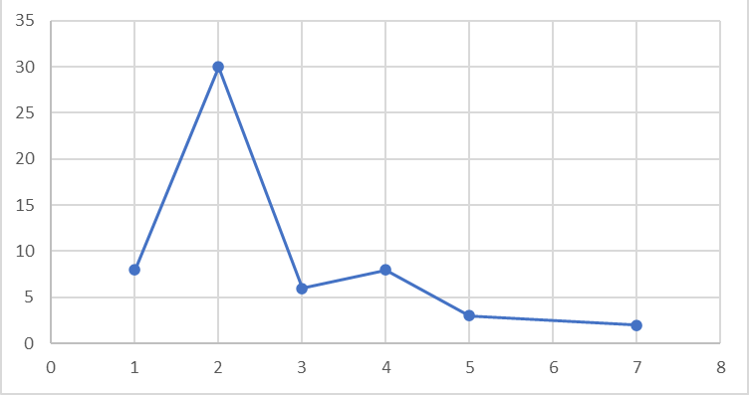
# of people in the household

- What other improvements do you hope to see in the Village of Coleman? (Written Responses)

Village of Coleman – Community Feedback Summary
Residents provided a wide range of comments on the current state of the Village of Coleman. While several expressed complete satisfaction with the community, most identified specific improvements they would like to see. The feedback can be grouped into the following major categories:

Infrastructure & Utilities
- Repair and upgrade roads, with emphasis on Main Street.
- Improve sidewalks and add better street lighting for nighttime safety.
- Replace aging stormwater and underground water pipes to prevent system failures.
- Consider burying power lines to reduce storm-related outages.
- Lower water/sewer bills and provide clearer, more transparent billing.
- Offer system updates and treatment plant tours for public understanding.

Public Safety
- Increase police presence and speed enforcement, especially on Main Street.
- Enforce regulations on tailgating and loud vehicle mufflers.
- Add safer pedestrian crossings, particularly for students.
- Provide wellness checks for elderly residents during severe weather.

Property Maintenance & Appearance
- Address run-down homes and poorly maintained properties.
- Remove abandoned structures such as the old gas station and old furniture building.
- Improve overall property upkeep throughout the village.

Community Amenities
- Strong interest in a splash pad and dog park.
- Desire for more walking/biking paths, better sidewalks, and dog waste stations in parks.

Housing & Economic Development
- Increase available apartments, family housing, and general living spaces.
- Encourage new businesses, restaurants, and more local shopping.
- Improve job opportunities and expand daycare options.

Community Services & Communication
- Improve internet access across the village.
- Increase transparency and communication between village leadership and residents.
- Encourage more community involvement and engagement.
- Library improvements requested, including expansion or a return to an independent library.

Aesthetic Improvements
- Replace aging garland-style Christmas lighting.
- Enhance Main Street aesthetics and general beautification.

- Additional Comments/Concerns

Summary of Community Comments and Concerns

Overall Community Sentiment
- Many residents express strong satisfaction with living in Coleman, describing it as friendly, safe, clean, and well-run.
- Several comment that “life is good” and they appreciate village efforts such as mowing, snow plowing, and gardening.

Taxes, Utilities & Services
- Requests to lower homeowner taxes.
- Mixed feedback on water/sewer rates—some understand the increase but hope for more residents and businesses to help share costs.
- Requests to eliminate online utility payment convenience fees.
- Desire for more access to the recycling center and for trash roll-back dumpsters to be available there.

Infrastructure & Public Works
- Concern about storm drain maintenance and clarification on whether the village or homeowners are responsible.
- Requests for cleanup of neglected properties, especially the Hannon property.
- Suggestions to clean up and improve Skarda Park, including adding trails.
- Ongoing issues with heavy truck traffic on Main Street.

Public Safety & Enforcement
- Strong request for increased policing on West Main Street due to speeding.
- Concerns about uncontrolled dogs running loose and leaving waste on private property.
- Requests for deer control measures.
- Comments on street parking being misused as an extension of private driveways.
- Concerns about yards displaying flags with profanity in areas with children.

Community Amenities & Development
- Interest in additional services and development, including:
  - A second gas station to help reduce fuel prices.
  - A splash pad or pool.
  - A 55+ mixed housing community.
  - A community center.
  - A park-and-ride location.
  - More family housing to attract younger residents.

Recreation & Environment
- Desire for safer walking environments:
  - Better crosswalks, especially across the railroad (CP).
  - Improved sidewalks for pedestrians.
- Interest in adding public fruit trees or bushes, acknowledging the potential for mess.

Communication & Community Engagement
- Requests for a Village Facebook page focused on events, announcements, and community information.
- Desire for more communication that supports a welcoming and connected community.

Rural Character & Growth Balance
- Residents want to maintain Coleman’s rural, quiet, low-crime character.
- At the same time, they recognize the importance of attracting families and sustainable growth.

